FALL 2024  
MEC325: INTRODUCTION TO ENGINEERING DESIGN  
DESIGN PROJECT  
**MILESTONE REPORT 2**



Assistive Transport of Children

when Walking

TEAM 1305

# team declaration

We, the undersigned members of Team 1305 in MEC325, agree that all team members have abided by all Toronto Metropolitan University Policies and course rules.

We furthermore accept that any violation of Toronto Metropolitan University Policy or course rules will lead to a grade penalty or charges of academic misconduct.

| STUDENT NAME | STUDENT NUMBER[1] |
| --- | --- |
| Khiem Nguyen | 13735 |
| Osama Noureddin | 46598 |
| Codin Nguyen | 37911 |
| Yee Yin Kwok | 51256 |
| Osman Asif | 35477 |
| Andrej Draskovic | 32844 |

# 

# table of contents

**team declaration 1**

**table of contents 1**

**executive summary 2**

**design brief summary 3**

**background 4**

Goals 4

Environment 4

Competition 4

Users 5

Strategy 5

**personas & SUCs 6**

Persona: John 6

Persona: Rachel 7

Persona: Margaret 8

Persona: Jameson 9

Persona: Thanh 10

Persona: Caitlynn 12

**requirements 14**

**design concepts 17**

design concept 1 17

design concept 2 20

design concept 3 23

design concept 4 27

design concept 5 30

Brief Explanation of Creativity Methods Used 32

Summary of Improvements Since Loop 1 33

design concept 6 34

**design issues 37**

**CEC Analysis Charts 38**

DC-1 CEC Analysis (OSMAN): 38

DC-2 CEC Analysis (OSAMA): 41

DC-3 CEC Analysis (CODIN): 44

DC-4 CEC Analysis: Andrej 48

DC-5 CEC Analysis (Khiem): 52

DC-6 CEC Analysis (Yee Yin): 55

**references 59**

# executive summary

As stated in the [Design Brief](https://docs.google.com/document/u/0/d/1m8Y97Fyu418LrBMM7_kaH58dcY6xXEpoC8NbKqFQzBs/edit), the primary concern of this project is the design of an Assistive Transport for Children when Walking. Outlined in the Design Brief Summary(pg. 3) are all specific factors and goals that needed to be met.

After several Situation Scans outlined in the Background(pg. 4), the final intervention needed to match several use cases. It needed to be usable in a multitude of environments, ranging from urban streets and public transports to rural roads and off-road environments [1]. Users would include primarily caregivers from ages 20-45, and co--users would be children up to the age of 5 [1].

Through research, several [Requirements](https://docs.google.com/document/d/1koir-KUa0VVEAbeYr69YBJmGd06drHKx8WeN1O9Ox0A/edit?tab=t.0) were developed in order to properly design a fitting solution. Requirements were separated into 5 categories: Functionality, Usability, Productibility, Maintainability, and Sustainability. Examples of these include automatic safety locks, easy disassembly, easily replaceable parts, a seat that can recline to 180 degrees, and be made of at least 50% recycled materials [1], in respective order.

Using the Requirements, [Design Concepts](https://docs.google.com/document/d/11n6DQ0O94_Z2QNZ97z0tFzYlL7ogNq-qIhy6Vw0yxTM/edit?tab=t.0)(Loop 2) were initially drawn out in Milestone 1. Each design had a very similar shape and function, similar to the Stroller. They differed in a key feature. These features include a foldable/unfoldable seat, push-button swivel wheel for low turn radius, spring suspension, backwards folding, and compact folded designs. However, a common issue was a reliance on the existing “stroller” design.

[Design Issues(pg. 34)](https://docs.google.com/document/d/11p1CeI0JZ8EviekQZd86UTYaauIlx_qG35qcVFyoaBc/edit?tab=t.0) were created for the previous concepts, and they were then edited for Milestone 2. Here they differ much more, and offer many more features for the user. These include a magnetic levitation suspension system, hovercraft movement, all-terrain treads, spring folding, folding buttons, and motorized movement. To further analyze the concepts, Human Factors and Exclusivity analysis(pg. 37) was performed using the Cambridge Exclusion Calculator [4]. This was then used to find new design issues to be further improved upon in the next milestone. .

# design brief summary

The design brief concerns the creation of Assistive Transport for Children when Walking ([Design Brief](https://docs.google.com/document/u/0/d/1m8Y97Fyu418LrBMM7_kaH58dcY6xXEpoC8NbKqFQzBs/edit)). The objective is to design a human-powered vehicle for newborn to toddler-aged children. This includes strollers, baby carriages and other potential interventions [5].

Strollers provide a safe way for caregivers to transport their children and be with them while allowing mobility. While they differ in cost and quality, the same basic needs all need to be met. These include the comfort of caregiver and child, storage solutions, ease of use, and affordability, to name a few. The inclusion of many different users is also a necessity, as is storage.

A NGO came forward with a request for a design proposal for a stroller. They had many concerns about accessibility, sustainability, and comfort. Ultimately, our team these aspects most important [5]:

* Include more people as users
* Ensure ethical and sustainable practices throughout lifecycle
* Usable by a single untrained person
* Remain safe in all real world use scenarios
* Account for Human Factors in all stages of use and lifecycle

The goal is to design a human-powered vehicle for newborn to toddler-aged children that enhances the usability, safety, and comfort of traditional strollers while accommodating a broad range of caregivers. This vehicle must be easy to operate by a single untrained user, addressing real-world challenges like public transit, hikes, and public spaces. It should be durable, affordable, and adaptable to the diverse needs of families, including multiple users such as siblings or grandparents. Prioritizing low environmental impact, safety, and ethical considerations throughout its life cycle, the design must also improve the comfort and dignity of both users and co-users [5] ([SKB: goals](https://docs.google.com/document/d/1rz1rAIiTk1ZrDwnuDpjA3R7Bg03I_6vg5hg59ztqgEg/edit?tab=t.0#bookmark=id.2fbkymz6klj8)).

# background

#### Goals

* **Design Objective:**
  + Develop a versatile, human-powered vehicle for newborns to toddlers, enhancing safety, comfort, and usability for diverse caregivers.
  + Must be easy to operate, durable, adaptable, affordable, and environmentally friendly, with a focus on safety and ethical considerations [1].

#### Environment

* **Urban/Suburban:**
  + Durable, weather-resistant materials, easy maneuverability for crowded or uneven surfaces, with features like built-in reflectors for low light [1].
* **Public Transport/Travel:**
  + Compact, easy-to-fold for storage in tight spaces, weather protection for outdoor transitions [1].
* **Rural/Off-Road/Beaches:**
  + Larger wheels, advanced suspension for rough terrain, UV-protective canopy for sun, weather-resistant designs for different environments [1].
* **Home:**
  + Maneuverability on various floor types, compact for storage [1].

#### Competition

* **Common Features:**
  + Waterproof materials, adjustable harnesses, durable frames, and large wheels for different terrains [1].
  + Popular designs like **UPPAbaby Vista V2** (expensive, versatile), **Jogger City Mini GT2** (lightweight, easy-fold), and **BOB Gear Revolution Flex 3.0** (rugged, premium materials) show the range of features addressing different user needs [1].
* **Examples:**
  + **Silver Cross Wave:** Premium, high-quality, comfort-focused.
  + **GB Pockit+ All-City:** Ultra-compact, ideal for tight spaces and urban travel [1].

#### Users

* **Primary Users:**
  + Caregivers (20-45 years), from diverse socio-economic backgrounds with varying physical abilities [1].
  + Features must accommodate different heights, strength, and cognitive factors, ensuring ease of use, especially for those with mobility impairments [1].
* **Co-Users:**
  + Children’s safety and comfort are priorities, while design must also allow for multiple caregivers (e.g., grandparents, siblings) [1].

#### Strategy

* **Market Segment:**
  + Targeting caregivers aged 20-45 in urban, suburban, and rural settings, focusing on versatile, weather-resistant, and ergonomic designs suitable for various environments [1].
* **Degree of Innovation:**
  + Combining features from existing strollers into a modular, ergonomic design that adapts to both the primary user (caregiver) and secondary user (child), with eco-friendly materials [1].
  + Features like adjustable seating, compact folding, and a suspension system will ensure comfort and versatility across terrains [1].
* **Time to Market:**
  + 3-4 years (Years 1-2 for research and development, Years 3-4 for testing, feedback, and adjustments) [1].
* **Production:**
  + Estimated annual production of 700,000 strollers based on industry standards and competitor analysis [1].
* **Customization:**
  + Modular components for customizable seating and maneuverability, catering to a broad user base across different environments and preferences [1].

# personas & SUCs

## Persona: John

**Background:** John is a 42-year-old male living with his 2-year-old toddler in a compact apartment complex with minimal storage. John is a single father who works from home and manages both his graphic designing job and the caretaking of his toddler. John is quite busy with his job in order to provide for his toddler, despite that John makes as much time as he can to take his toddler for walks. John has a significant and frequent need for long walking commutes in order to reach places such as grocery stores, John also takes his toddler with him on these commutes. Due to John's recent back surgery, it prohibits him from lifting heavy objects and limits movement to prevent any pain from occurring. Furthermore, John is a tall individual, at 188 cm needing a design that accommodates above average heights in order to comfortably maneuver with the device. John faces the challenge of maneuvering through the busy and uneven terrain of the city and due to his lack of strength, John stresses the need for high-stability in order to prevent tipping or uncomfort for his toddler.

| **SUC 4** | **John takes his toddler with him to the grocery store** |
| --- | --- |
| **Owner** | Osman |
|  | On a typical afternoon John needs to go grocery shopping, taking his toddler along with him. Traversing the busy streets of the city he walks through the rough and uneven terrain. John walks through several blocks, ensuring his toddler is comfortable and shaded well from the blazing sun using an umbrella. Due to his back injury, John struggles with pushing the device with the necessary force consistently, which creates a more difficult ride for him and his toddler. Furthermore, due to his staggering height, the handlebars are positioned quite low for him, creating an unnatural wrist position and putting extra strain on his back and shoulders. After arriving at the grocery store, John carries his groceries in the bags given which add onto the weight and strain on John. After arriving home, John struggles in accommodating a compact area for the design, resulting in a larger space being occupied then intended.  **Relevance:** This Scenario highlights the importance of an intervention that incorporates many aspects that allow for an easy, safe and comfortable experience for John and his toddler. As John goes on his grocery trip, an intervention that is capable of long rides without fail, for long-term use without major wear and tear is necessary for John. Furthermore, an intervention that has high stability through a variety of terrains allows for easy maneuverability through the busy and unpredictable city streets. Additionally, a means to add in creating less force required to push the assistive transport aids John to not be prone to injury and allow for a more safe ride. Adjustable handlebars are also essential for John’s height allowing for neutral wrist position and less strain on his back. Lastly, a means of storage is essential for the intervention, allowing for means to store the grocery without having to carry it while maneuvering the design. |

## 

## Persona: Rachel

Rachel is a 35 year old female who regularly takes care of her 3-year old niece. She recently quit her full time job at Tim Horton’s due to worsening multiple sclerosis which causes her to lose balance after standing on her feet for an extended period of time. She hopes to find a new job, but in the meantime she spends her time playing dungeons and dragons in her best friend's basement. After the birth of her sister’s son, going on walks in the park with her niece has been almost the only time that she spends time outdoors. She especially struggles to leave the house during the rain, as her thick prescription glasses are impossible to see through when wet, and she is unable to wear contacts due to the dexterity required to put them on.

| SUC 2 | Rachel taking an up-hill route while on a walk with her niece |
| --- | --- |
| Owner | Osama |
|  | Rachel’s niece decides she wants to take a new route on their weekly walk, and this new route involves an uphill portion. Relevance: Rachel will have to use extra force to push the intervention and must stabilize it from falling for an extended period of time. |

## Persona: Margaret

Margaret is a 68-year-old woman who lives alone but often cares for her 2-year-old granddaughter, Emily, while her daughter is at work. Margaret was diagnosed with early-stage dementia two years ago, which occasionally affects her short-term memory and makes complex tasks a little confusing. Despite this, she is strong and active, walking daily and enjoying gardening to stay physically fit and mentally engaged. She values her independence and is determined to keep doing things on her own as much as possible. Margaret prefers walking to driving, finding it simpler and safer. She often takes Emily to the park. Margaret is deeply caring and patient, and time spent with Emily is something she treasures. It’s a reminder of all the meaningful connections in her life, and she feels grounded and purposeful caring for her granddaughter. As her condition progresses, Margaret looks for tools and products that allow her to remain involved with her family safely and independently, finding joy in the little moments with Emily.

| **SUC 3** | Margaret takes Emily to the park in the afternoon |
| --- | --- |
| **Owner:** | Codin |
|  | On a sunny afternoon at 3:00 p.m., Margaret, a 68-year-old with early-stage dementia, sets out with her 2-year-old granddaughter, Emily, for a walk to the park. She values her independence, and walking feels safer and simpler than driving, especially with Emily in tow. Margaret brings along a lightweight device and a small backpack packed with essentials for their outing.  As they make their way down the sidewalk, Margaret starts to feel a bit tired and thirsty. She spots a bench up ahead and decides to take a quick break. Carefully positioning the device beside her, she sets the brakes to keep Emily secure before digging through her backpack for her water bottle. After a few moments of searching, she finally finds it, taking a sip and feeling a bit refreshed. Rested, Margaret continues on to the park, where she and Emily spend a joyful afternoon together.  **Relevance**: This scenario highlights the importance of an intervention that supports Margaret’s physical and cognitive needs, ensuring both safety and ease of use. As Margaret becomes tired during the walk, she benefits from an intervention that’s lightweight and easy to control, minimizing physical strain. The device’s secure brakes provide peace of mind when she needs a rest, while an accessible and organized storage compartment would help her locate essentials quickly, reducing frustration and distraction. Additionally, simple visual cues or labels could aid Margaret in using the device confidently, even with memory challenges. These features would allow Margaret to enjoy outings with Emily independently and safely. |

## Persona: Jameson

**Background:** Jameson is a 84 year old man who retired from his assembly line job 5 years ago. Since he now stays at home, he cares for his 2 year old grandson George from time to time. Due to his long and tough career, he has developed many chronic physical pain conditions in his back and knees, making leaning over and pushing heavy objects difficult and painful. As well, he is experiencing muscle degradation due to his age, sapping him of strength. Along with his strength, his eyesight is slowly failing. However Jameson is a stubborn man, so he refuses to wear glasses. When taking Goerge outside, he cannot carry him around, instead needing a device to move him. Not only does it need to be light for Jameson to safely operate it, but it must have very large and easy to use functions. As well, Jameson is very suspicious of new technology, so it must be very simple to understand.

| **SUC** | **Jameson goes to get groceries with his grandson** |
| --- | --- |
| **Owner:** | Andrej |
|  | 84-year old Jameson takes his grandson George on a quick grocery trip around the block. Since he cannot legally drive, he needs to get there and back with both Geroge and the groceries in tow. Due to his lack of strength and vision, the lightweight device with easy to read instructions is a lifesaver. As well, when he gets to his rather small bungalow, the simple folding mechanism lets him understand the instructions and save space.  **Relevance:** This scenario shows many important factors that need to be considered when designing the intervention. FIrstly, it must be very light and maneuverable in order for people with low or degrading strength to use it/keep using it. Instructions need to be high contrast and large for people with vision disabilities. Large amounts of storage space is a huge bonus for Jameson, who needs it for groceries and other errands. A simple and effective folding mechanism is also necessary for small living areas like Jameson’s home. |

## Persona: Thanh

Thanh Nguyen is a 32-year-old software developer who moved from Vietnam to Toronto three years ago with his wife. Since moving, he’s been adjusting to life in a busy city, learning new routines and working on his English skills. His limited proficiency in English makes following complicated written instructions difficult, especially for devices with multiple steps. Thanh was also born without his right forearm, which he’s adapted to by relying heavily on his left hand for almost all activities. While he’s usually confident handling most tasks, pushing a device through Toronto’s crowded streets is challenging without a second hand to assist.

| **SUC 2** | Thanh Navigates Busy Toronto Streets with a Device on a Rainy Day |
| --- | --- |
| **Owner:** | Khiem |
|  | On a bright Saturday morning, Thanh sets out with his son, Duy, for a walk to the local park. Living in Toronto, Thanh navigates crowded sidewalks, steering the device with his left hand—his only hand, as he was born without a right forearm. He values his independence and enjoys outings with Duy, although busy streets and crosswalks require extra focus and care as he adjusts the device with just one hand. Thanh brings along a lightweight device and a small backpack with essentials for their day.  As they approach the park, Thanh spots a few steps leading up to the entrance and realizes there’s no ramp. To continue, he needs to fold the device with one hand and carry it up the steps. Given his one-handed use and that English is not his first language, he relies on clear, picture-based instructions to understand the device’s features smoothly and efficiently. After a brief pause, he completes the task and they continue to enjoy the park.  **Relevance**: This scenario highlights the need for a device that supports Thanh’s physical and language needs, providing both functionality and ease of use. A lightweight design reduces physical strain, and one-handed operation for steering and folding allows Thanh to maneuver smoothly. Foot-activated brakes offer quick and reliable security when needed, and well-designed visual instructions eliminate language barriers, enabling Thanh to operate the device confidently. These features would allow Thanh to fully enjoy outings with Duy, with minimal obstacles. |

## Persona: Caitlynn

**Background**: Caitlynn is a 40 years old stay at home mother who recently had a child. She lives with her spouse however they are not at home often as they work long hours. Due to a severe car accident in her 30’s she is missing her right leg and has phantom pain and is physically weak. She has some difficulty walking as she biases her remaining leg as it hurts for her to walk on the prosthetic. Despite her disability she prefers to walk and take public transport over driving on her own. She is strong willed and prefers to do things on her own without the help of others, often going to buy groceries on her own despite her spouse's protests.

| **SUC** | Caitlynn goes on a errand run on a cold rainy day |
| --- | --- |
| **Owner:** | Yee Yin |
|  | On a cold fall afternoon Caitlynn needs to go and run some errands nearby. She can’t leave her child alone at home so she has to bring them with her. On this day it was raining quite heavily, and was quite cold so the ground was a bit slippery. As Caitlynn is missing a leg, she gets occasional pain as a result of the change in pressure from the weather. Today was one of those days. Caitlynn brings the vehicle with her to help to carry anything she buys on her trip to the store. As she begins her walk, the slippery sidewalks and the ache in her leg slow her pace. However, the vehicle's assistive walking mechanism, enables Caitlynn to maintain a steady, moderate pace even on days when her mobility is compromised. The mechanism reduces the amount of physical effort needed to push the vehicle, providing some relief as she navigates the slick, wet ground.  **Relevance**: This scenario highlights the importance of an intervention that will help those with any difficulties pushing the vehicle. As Caitlynn has a physical disability and lives in an area with less than ideal climate, she will benefit from an intervention that will assist her in propelling the stroller forward when she is having difficulties. |

# 

# requirements

**Internal Requirements**

**Functionality**

1. Automatic Safety Locks
   * + This ensures safety by preventing accidental folding. See [SKB 4.7](https://docs.google.com/document/u/0/d/1YEjEXJfWXH6WhaKF20ACS39N4-rEMIp-a03EXtmuQ7s/edit).

**Producibility**

1. The intervention must be designed for easy disassembly
   * + To ensure ease of repair and maintenance
2. The intervention must use all aluminum tubing frame
   * + See [SKB 6.1](https://docs.google.com/document/u/4/d/1YEjEXJfWXH6WhaKF20ACS39N4-rEMIp-a03EXtmuQ7s/edit).
3. The intervention must use injection molding for all plastic parts
   * + To ensure easy manufacturing
4. The intervention must use off the shelf fasteners
   * + To ensure ease of repair and maintenance

**Maintainability**

1. The intervention must have easily replaceable parts
   * + To improve maintainability

**Situational Requirements**

**Functionality**

1. The intervention must have folding mechanism
   1. The intervention must fold to fit within an 9 cubic feet space
      * This ensures the intervention is compatible with the majority of trunks, improving ease of use. See [SKB 4.2](https://docs.google.com/document/u/0/d/1YEjEXJfWXH6WhaKF20ACS39N4-rEMIp-a03EXtmuQ7s/edit).
2. The intervention must secure a occupant ranging from infant to small child
   1. The intervention must hold at least 100 lbs with no more than 1 infant/ small child
      * See [SKB 3.1.1](https://docs.google.com/document/u/0/d/1YEjEXJfWXH6WhaKF20ACS39N4-rEMIp-a03EXtmuQ7s/edit).
3. The intervention must have separate storage compartment
   * + See [SKB 2.3](https://docs.google.com/document/u/4/d/1YEjEXJfWXH6WhaKF20ACS39N4-rEMIp-a03EXtmuQ7s/edit).
4. The intervention must have an UPF rating no less than 40
   * + See [SKB 6.2](https://docs.google.com/document/d/1YEjEXJfWXH6WhaKF20ACS39N4-rEMIp-a03EXtmuQ7s/edit).
5. The intervention must have a suspension system
   * + See [SKB 2.2](https://docs.google.com/document/u/4/d/1YEjEXJfWXH6WhaKF20ACS39N4-rEMIp-a03EXtmuQ7s/edit).
     + See [SKB 4.1](https://docs.google.com/document/u/4/d/1YEjEXJfWXH6WhaKF20ACS39N4-rEMIp-a03EXtmuQ7s/edit).
6. The intervention must have a braking system
7. The intervention must move
   1. The intervention must have a control and steering system
      * This ensures maneuverability and enhances control for easier use. See [SKB 4.8](https://docs.google.com/document/u/4/d/1YEjEXJfWXH6WhaKF20ACS39N4-rEMIp-a03EXtmuQ7s/edit).
   2. The intervention must move at the speed at which the user walks with reasonable force which the user produces when walking
      * [SKB 4.9](https://docs.google.com/document/u/4/d/1YEjEXJfWXH6WhaKF20ACS39N4-rEMIp-a03EXtmuQ7s/edit).
   3. The intervention must have a minimum turning radius of 4 feet
      * [SKB 5.6](https://docs.google.com/document/u/4/d/1YEjEXJfWXH6WhaKF20ACS39N4-rEMIp-a03EXtmuQ7s/edit).

**Usability**

1. The intervention must be accessible and reliably fold
   * + See [SKB 4.2](https://docs.google.com/document/u/4/d/1YEjEXJfWXH6WhaKF20ACS39N4-rEMIp-a03EXtmuQ7s/edit).
     + See [SKB 4.3](https://docs.google.com/document/u/4/d/1YEjEXJfWXH6WhaKF20ACS39N4-rEMIp-a03EXtmuQ7s/edit).
2. The intervention must provide shade and weather protection
   * + See [SKB 2.1](https://docs.google.com/document/u/4/d/1YEjEXJfWXH6WhaKF20ACS39N4-rEMIp-a03EXtmuQ7s/edit).
3. The intervention must have an adjustable footrest
   * + See [SKB 2.1](https://docs.google.com/document/u/4/d/1YEjEXJfWXH6WhaKF20ACS39N4-rEMIp-a03EXtmuQ7s/edit).
     + See [SKB 4.6](https://docs.google.com/document/u/4/d/1YEjEXJfWXH6WhaKF20ACS39N4-rEMIp-a03EXtmuQ7s/edit).
4. The intervention must follow ASTM International Stroller Safety Standards, ASTM F833-21, chapters 6 for performance standards
   * + See [SKB 3.1](https://docs.google.com/document/u/0/d/1YEjEXJfWXH6WhaKF20ACS39N4-rEMIp-a03EXtmuQ7s/edit)
5. The intervention must have a seat that can recline 180 degrees
   * + See  [SKB 2.1](https://docs.google.com/document/u/4/d/1YEjEXJfWXH6WhaKF20ACS39N4-rEMIp-a03EXtmuQ7s/edit).
6. The intervention must have caster angles between 2-4 degrees on the front tires
   * + See [SKB 5.5](https://docs.google.com/document/u/4/d/1YEjEXJfWXH6WhaKF20ACS39N4-rEMIp-a03EXtmuQ7s/edit).
7. The intervention must have adjustable seating heights
   * + See [SKB 2.1](https://docs.google.com/document/u/4/d/1YEjEXJfWXH6WhaKF20ACS39N4-rEMIp-a03EXtmuQ7s/edit).
8. The intervention must have height and length adjustable handle bars
   * + See [SKB 2.3](https://docs.google.com/document/u/4/d/1YEjEXJfWXH6WhaKF20ACS39N4-rEMIp-a03EXtmuQ7s/edit).
     + See [SKB 4.6](https://docs.google.com/document/u/4/d/1YEjEXJfWXH6WhaKF20ACS39N4-rEMIp-a03EXtmuQ7s/edit)**.**

**Productibility**

1. Materials used must comply to ASTM International Standards for Material Safety, ASTM F1004
   * + See [SKB 3.1](https://docs.google.com/document/u/0/d/1YEjEXJfWXH6WhaKF20ACS39N4-rEMIp-a03EXtmuQ7s/edit).

**Maintainability**

1. The intervention must be resistant to fluids
   * + See [SKB 6.2](https://docs.google.com/document/u/4/d/1YEjEXJfWXH6WhaKF20ACS39N4-rEMIp-a03EXtmuQ7s/edit).
2. The intervention must be able to be cleaned easily
   * + See [SKB 6.2](https://docs.google.com/document/u/4/d/1YEjEXJfWXH6WhaKF20ACS39N4-rEMIp-a03EXtmuQ7s/edit).
3. Fabric cover must be machine washable
   * + See [SKB 6.2](https://docs.google.com/document/u/4/d/1YEjEXJfWXH6WhaKF20ACS39N4-rEMIp-a03EXtmuQ7s/edit).
4. The intervention must have easily replaceable parts
5. The intervention must feature non-corrosive materials
   * + See [SKB 6.1](https://docs.google.com/document/u/4/d/1YEjEXJfWXH6WhaKF20ACS39N4-rEMIp-a03EXtmuQ7s/edit).

**Sustainability**

1. The intervention must consist of minimum of 50% recycled material
   * + To ensure reduced emission by using recycled materials
2. The intervention must include a take-back program
   * + To ensure reduced waste
3. The intervention must be packaged in biodegradable packaging
   * + See [SKB 6.3](https://docs.google.com/document/u/4/d/1YEjEXJfWXH6WhaKF20ACS39N4-rEMIp-a03EXtmuQ7s/edit).
4. The intervention must have minimal packaging
   * + See [SKB 6.3](https://docs.google.com/document/u/4/d/1YEjEXJfWXH6WhaKF20ACS39N4-rEMIp-a03EXtmuQ7s/edit).
5. The intervention must have a refurbish program
   * + To ensure reduced waste

# design concepts

## design concept 1

Osman Asif’s design concept

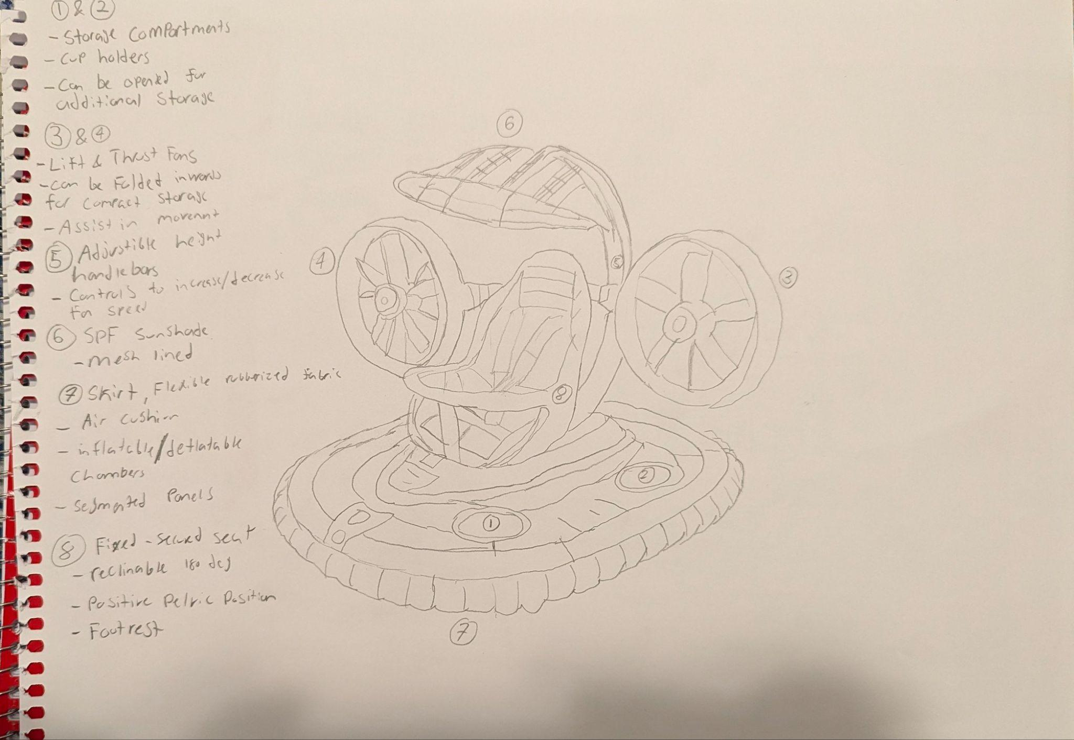

**Description:** The advanced intervention integrates comfort, functionality and usability in a high-tech manner. The intervention includes various modular components aimed at providing ease of mobility and stability across long travels. The intervention features thrust & lift fans positioned on either side in order to add a propulsion system to aid significantly in movement. Additionally the fans can be adjusted for different heights allowing for adaptation to various terrains and as well as folded inwards for compactness. Furthermore, the adjustable handlebars behind the fans allow for adjusted height and length when pushing the intervention allowing for a comfortable position for the user, it also includes controls for the fan speed and on/off controls for the fans if they are not needed or are required to spin faster. Moreover, the air cushioned skirt, creating the base of the intervention works alongside the fans, similarly to a hovercraft in order to create a frictionless area to allow for a smooth ride through rough terrain. Furthermore, the skirt is made of flexible, rubberized fabric that has air cushioning and inflatable/deflatable air chambers that can be adjusted for compactness. The intervention has two storage compartments that can be used as cup holders or opened for greater storage access to hold essential items for the child or the parent. The sunshade using mesh-lining allows for protective material against UV rays for the child and creates a safe environment for them. Lastly, the seat is securely fixed and possesses fastened seat belts ensuring maximum safety as well as reclinable options up to 180 degrees, ensuring a positive pelvic position.

To improve from design 1, design by analogy was used, in order to implement a design that allows for easy mobility of the intervention, by using aspects from a hovercraft, the thrust fans and the air skirt in order to create a smooth, innovative design. Through the use of design by analogy the intervention uses the fans in order to propel forward and aid in pushing it, furthermore, the use of the air skirt allows for a smoother, frictionless ride over different terrains with improved comfortability and ergonomics. Moreover, rather than focusing on the norms of designs present right now, the focus was more leaned towards an innovative design that accommodates the same needs in a more efficient, productive and unique manner.

**Usage Scenario**

1. Setup
2. Unfold the thrust fans fully outwards and lock into place, positioning them parallel to the seat
3. Adjust the height of the fans as well as the handlebars to ensure comfortable position
4. Inflate the skirt for use and shock absorption
5. Adjust the sunshade canopy position in order to accommodate the child's needs
6. Adjust the modular seat position
7. Place the child inside, with the safety harnesses on tightly
8. Store any essential items in the storage compartment
9. Use
10. Use the controls on the handlebars to adjust the fan speed as needed for assistance in propulsion
11. Push the intervention forward using the air cushioned flexible skirt, providing a frictionless, smooth ride, absorbing shocks and bumps
12. Use a control on the handlebar to spin fans in the opposite direction of travel in order to act as a means to impede motion and act as a braking system
13. Put away
14. Remove child from intervention, ensuring the seat is locked in a fixed position
15. Deflate the air cushion for compactness
16. Fold in the fans towards the seat and lock them in place, lower the height to the lowest setting
17. Release the three locks on the frame of the seat, bringing it forward and locking it in place
18. Place the intervention in storage ensuring it is secure and stable

## 

## design concept 2

Osama Noureddin’s Design Concept

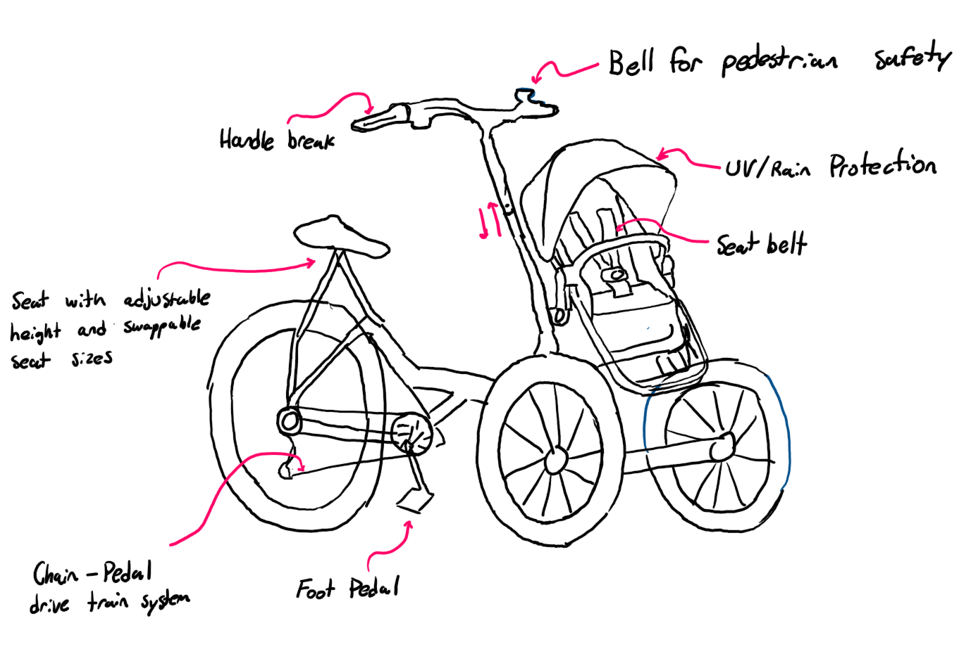

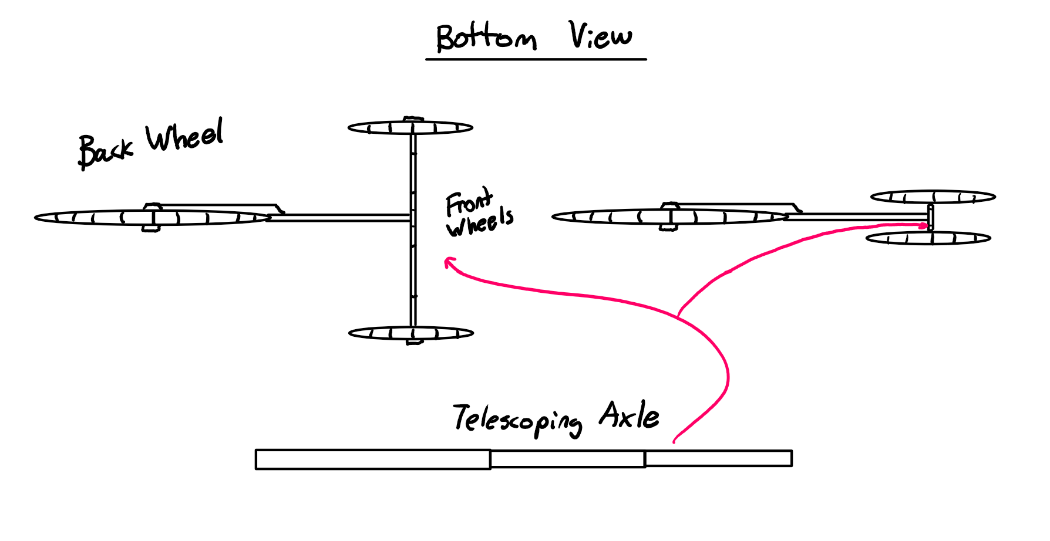

**Description:**

The featured intervention is a three wheeled pedal vehicle with a child seated at the front. The design is ideal for traveling long distances at higher speeds without much effort, and is ideal for commuting. The 2 front wheels are smaller in size than the back wheel and remove the need for balancing such as in a bicycle. To accommodate for various users, the intervention features a swappable seat for either larger or smaller surface area depending on user’s bottom breadth, as well as adjustable seat and steering bar heights. For safety considerations, the intervention features rim brakes activated via a handlebar trigger, a bell to alert pedestrians, as well as a seatbelt for the child passenger/infant passenger. For ease of storage, the front axle of the intervention is telescoping such that the distance between the front two wheels can be reduced to take up less space. Only the rear wheel of the vehicle is powered by pedaling, and featured is a 7 gear system controlled by a rotary dial on the right handlebar, in which the lowest requires the least amount of force to pedal but also produces the least torque. A creativity method used to transition from the previous design iteration is **design by attribute**, in which the previous method of pushing and walking with the intervention was replaced by pedaling. This allows for the user to travel longer distances and at higher speeds while inputting less effort. Another key creativity method implemented is design by assumption, in which a function that was no longer valid was the overall need for the intervention to function like a stroller. When this assumption was voided, it allowed for the creation of the new vehicle design.

**Usage Scenario:**

1. Setup
   1. Pull apart front wheels until they lock in place
   2. Adjust seat and handlebars as necessary by pressing on spring buttons and pulling/pushing until desired setting
   3. Seat child in vehicle seat and harness seatbelt
   4. If necessary, adjust canopy such that child is protected from weather conditions
2. Use
   1. Sit on seat with hands on handlebars, fingers over breaks and feet on pedals
   2. Begin pedaling and steering intervention in desired direction
   3. To slow down, squeeze breaks
   4. After reaching a comfortable speed and pedaling becomes too easy, turn gear dial towards user to increase gear level
   5. When finished with ride, bring gear level back down to lowest before returning and parking
3. Put-Away
   1. Unbuckle and remove child from vehicle
   2. Press spring buttons on axle and collapse the wheels together
   3. Store intervention where desired

## 

## design concept 3

Codin Nguyen’s Design Concept

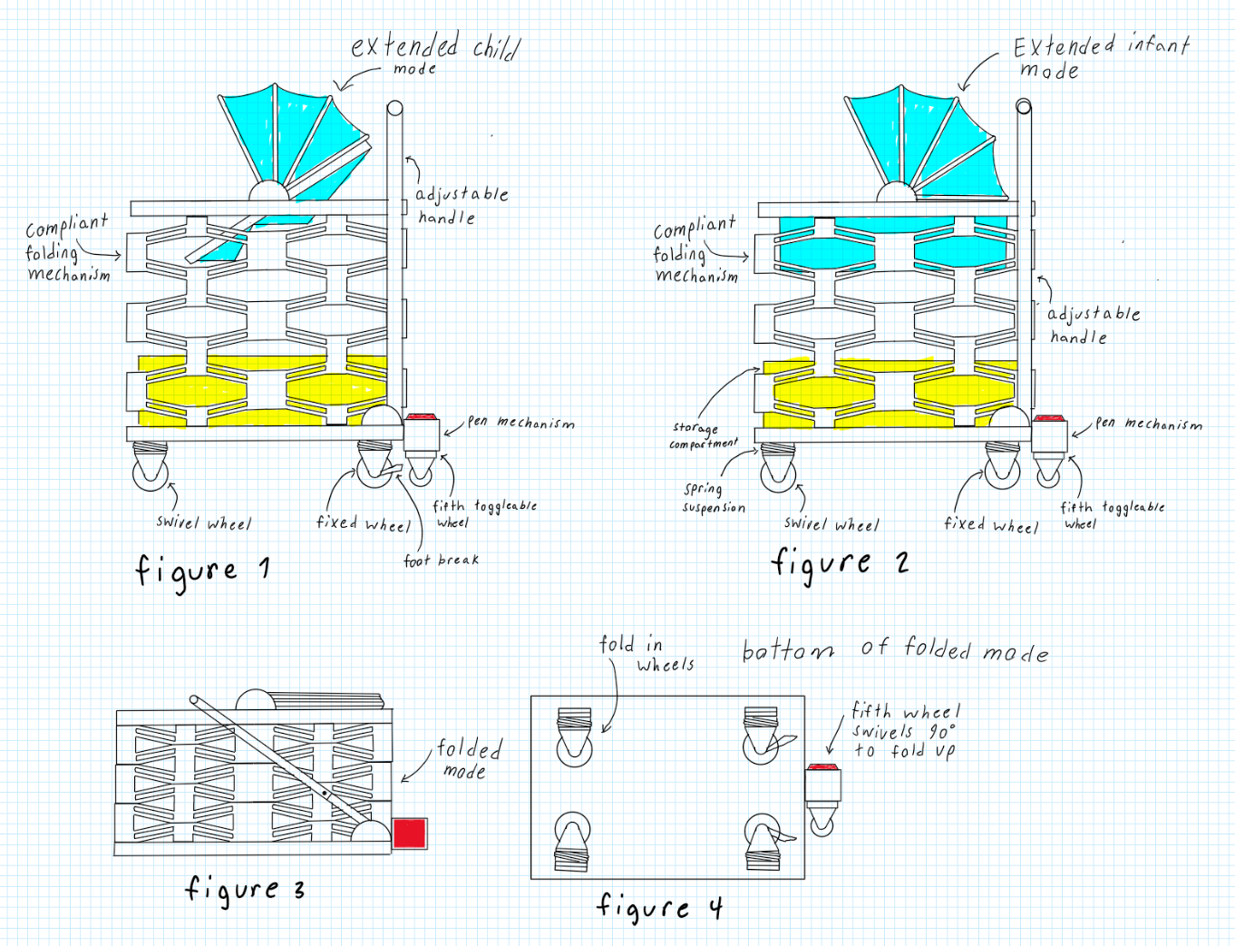

**Description:**

The design concept sketch introduces a five-wheel intervention with innovative features, including a transformable seat that shifts from a basket to a seat with a 40-degree incline (see Figures 1 and 2). This adaptability allows the intervention to accommodate a growing child over multiple years, eliminating the need for frequent replacements. A key feature is the deployable fifth swivel wheel, activated by pressing a red button. When deployed, the intervention balances on the fifth wheel and the two front swivel wheels, enabling omni-directional movement, which is ideal for navigating confined spaces like public transport (see Figures 1 and 2). Pressing the red button again smoothly retracts the fifth wheel, similar to a retractable pen. When the fifth wheel is disengaged, the intervention operates on two front swivel wheels with positive caster (see SKB 5.5 for caster specifications), while the two rear wheels remain fixed. The design also includes a reliable compliant folding mechanism with foldable wheels for compact storage. Foot brakes on each rear wheel (see Figures 1 and 4) provide secure locking—an essential feature for safety on inclined surfaces or public transport. An integrated seatbelt further enhances safety, preventing toddlers from falling out while the intervention is in motion.

To develop Concept 2, specific creativity methods were employed to enhance functionality, usability, and adaptability based on challenges identified in Concept 1. The SCAMPER Method proved particularly valuable in prompting innovative adjustments by asking questions such as, "What could we combine?" and "How can we improve safety?" This led to combining a compliant folding mechanism with foldable wheels, resulting in a more compact, user-friendly design.

The Challenge Assumptions method also played a role, particularly in rethinking traditional assumptions around stroller stability and maneuverability. By questioning the conventional four-wheel design, we introduced a fifth deployable swivel wheel that allows for omni-directional movement, enhancing control in confined spaces. This creative step offers better functionality in tight, urban environments, making the intervention more versatile for users.

Finally, Design by Attribute encouraged adjustments in the storage compartment’s design, seeking a solution that reduced bending and discomfort. By reconfiguring the layout and accessibility, the storage became easier to use while maintaining a low profile.

**Usage Scenario:**

1. Setup
   1. Fold Out the wheels
   2. Rotate the fifth wheel to be vertical
   3. Pull back handle to 1 o'clock position
   4. Press on handle side lock then extend handle out wards
   5. Extend the main body upwards
   6. Push handle to 12 o'clock position to lockin the main body
   7. Adjust seat to desired mode either small child mode or infant mode
2. Use
   1. Place child into the seat
   2. Secure child with the straps if in small child mode
   3. Adjust sunshade to desired coverage
   4. Place essential items in storage compartment located under to child seat
   5. Push the intervention by the handle to control and move the intervention
   6. When extra maneuverability is needed, step on the red button to activate the fifth wheel to deactivate the fifth wheel step on the red button again.
   7. Step on foot brake to anchor the intervention in place to unanchor the intervention lift the foot brake
3. Put away
   1. Remove child and essential items from the seat and storage compartment
   2. Adjust seat into infant mode
   3. Pull back handle to 1 o'clock position
   4. Collapse the main body down to its lowest position
   5. Collapse the handle
   6. Push the handle to the 10 o'clock to lock in the main body
   7. Rotate the fifth wheel to be horizontal
   8. Fold in the wheels

**Improvements since loop 1:**

In Concept 2, several design upgrades enhance usability, comfort, and safety. The compliant folding mechanism has been improved for greater reliability and ease of use, featuring foldable wheels that allow for more compact storage and simpler transport. The brake system has also evolved, with foot brakes on each rear wheel providing a secure, user-friendly locking mechanism, which is especially beneficial on inclined surfaces or public transport, as opposed to the force-applied braking in Concept 1. While the larger storage compartment still requires users to bend down, its design minimizes strain with an accessible layout that simplifies reaching for items. Adjustable handles now accommodate various user heights, reducing ergonomic strain and promoting comfort. Additionally, the new suspension system improves stability and offers a smoother ride over different terrains, reducing vibration fatigue for both the user and child.

## 

## design concept 4

Andrej Draskovic’s Design Concept

## 

**Description:**

The intervention is an assistive child carrying device to be used for moving or transporting a child. Its most prominent feature is the magnetic levitation suspension system (Figure 1). Using opposing magnets on the base and the main unit, the intervention can levitate. This system creates a smoother ride. Another large feature is the chest/stomach pushing area. Instead of relying on purely arm strength, the user can use their whole body to move the intervention, allowing for a greater user base. The pushing area is adjustable for height, as well as chest area. As well, the intervention uses a hybrid power system, assisting motion with two electric motors. These can be controlled using the two handles (Figure 3). Controls include an accelerator, brake, parking brake, and folding activator. All are easy to press and use. The folding mechanism is seemingly complicated with many moving parts, but all it requires is a press of the folding button. This electronically unlatches all the folding joints and turns off the magnetic levitation, allowing the two parts to be separated. The intervention then folds with a simple downwards push. The child carrying area is comfortable and large, allowing children of many ages and sizes to lie flat. The included sunshade protects from the weather and other elements. For storage, the large empty area under the child carrying area has netting, allowing for many large items to be stored. As it is not too low to the ground, minimal bending over is required.

In order to differ and improve the design from Milestone 1, several creativity methods were used. When coming up with the magnetic levitation suspension system, analogical design was used. Imagine driving a car that was so smooth, you would not feel anything from the road. The same concept can be applied to the given intervention. As well, design by attribute was used to come up with the chest pushing system. Swapping the handles for some other device that can utilize more of the body’s strength was the main goal, and pushing with the whole chest/body dawned as a great solution.

**Usage Scenario:**

1. Setup
   1. Recover intervention from storage space
   2. Unplug charger
   3. Press disassembly button
   4. Pull on the top, until all joints latch
   5. Place top part of the intervention on the base, magnetic levitation start
2. Use
   1. Place child into carry area
   2. Adjust sunshade as necessary
   3. Place any items in the storage area
   4. Place chest on pushing area, and hold both handles
   5. Disable parking brake, initiate accelerator while pushing
   6. To stop, initiate brake
   7. Steer by pushing intervention in desired direction, using motors for assistance
3. Put away
   1. Activate parking brake
   2. Remove child and any items stored within the intervention
   3. Activate folding button
   4. Remove magnetic levitation base
   5. Push down on intervention, making sure nothing snags while folding

## 

## 

## 

## design concept 5

Khiem’s design concept

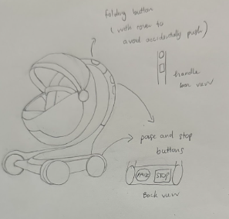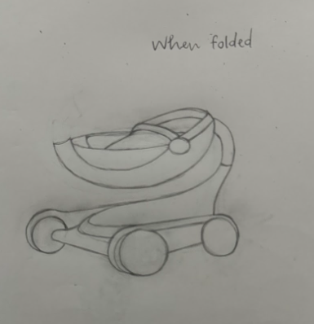

**Description:** It features an ergonomic, curved handle for easy steering and a built-in folding button that triggers a smooth, automatic fold. With a single press, the vertical support bar collapses downward, and the egg-shaped seating pod folds up over the base, creating a streamlined, easy-to-carry shape. For added convenience, each button on the pod provides audio feedback with spoken confirmations, which is especially helpful for users with visual impairments or anyone who prefers an extra layer of confirmation. The pod is weather-resistant and built with shock-absorbing materials, ensuring a smooth ride over wet or bumpy city streets. The device offers two braking modes for added safety and flexibility. In the “pause” mode, the device will temporarily halt, but it can resume movement if pushed with enough force. The second mode, a full stop, keeps the device stationary until the user presses the button again to resume motion. Additionally, slight motorized assistance reduces the physical effort needed, making it easier to navigate crowded sidewalks and inclines with minimal strain. Its low-profile, egg-like shape balances style, stability, and comfort, providing a modern and practical solution for urban baby transportation.

**Usage Scenario:**

**1. Setup**

* **a.** Unfold the pod by pressing the unfolding button; the vertical support bar will extend, and the egg-shaped seat will rise and lock into place.
* **b.** Adjust the handle height for a comfortable grip and ensure the ergonomic handle is positioned for one-handed use.
* **c.** Engage the shock-absorbing base to provide a smooth, stable ride over uneven surfaces.
* **d.** Adjust the sunshade canopy to provide optimal coverage based on lighting and weather conditions.
* **e.** Position the modular seat for comfort and security, adjusting as necessary for the child’s height and needs.
* **f.** Place the child in the seat, securing them with the harness to ensure a snug and safe fit.
* **g.** Store any essential items, such as bags or toys, in the designated storage compartment.

**2. Use**

* **a.** Use the handle to steer the pod, with motorized assistance providing a smooth, low-effort push.
* **b.** Adjust speed as needed with the built-in controls on the handle to match walking pace or navigate more challenging terrain.
* **c.** Engage the foot brake to control stops, using the braking system to decelerate smoothly when needed.
* **d.** Steer by applying gentle pressure on the handle; the motor assistance responds to each movement, ensuring smooth directional control.

**3. Put Away**

* **a.** Carefully remove the child, ensuring the harness is fully unfastened, and empty the storage compartment of any items.
* **b.** Engage the automatic deflation of the shock-absorbing base to compact the pod for storage.
* **c.** Press the folding button; the vertical support bar collapses, and the egg-shaped seat folds upward over the base for a compact shape.
* **d.** Lock the frame and ensure all components are securely in place to prevent accidental unfolding.
* **e.** Place the pod in the designated storage location, ensuring it is stable and ready for the next use.

### Brief Explanation of Creativity Methods Used

In designing the updated stroller, creativity methods were strategically applied to enhance both functionality and user experience. The **SCAMPER** technique proved invaluable, enabling a rethinking of key components. Traditional manual folding mechanisms were substituted with a single-button automatic system, allowing for smoother, one-handed operation. The stroller’s form was modified to a low-profile, egg-like shape that merges aesthetics with improved stability and maneuverability. Additionally, the ergonomic handle was adapted for one-handed steering, which supports easy navigation in crowded, urban environments. **Design Thinking** was central to shaping an accessible and user-friendly design. Emphasis was placed on incorporating audio feedback for each button press, aiding users who may benefit from spoken confirmations. This feature adds a layer of intuitive guidance, making the stroller more user-centric and straightforward in operation.

### Summary of Improvements Since Loop 1

**Enhanced Ergonomics and User Comfort**:  
The updated ergonomic handle provides better control and comfort, especially in crowded areas. Motorized assistance reduces physical effort, allowing smooth, low-effort navigation, particularly on inclines and rough surfaces.

**Improved Folding Mechanism**:  
The stroller now features a single-button automatic fold, making it quicker and easier to store. Its compact, egg-shaped pod design is optimized for urban spaces, creating a streamlined, easy-to-carry form.

**Increased Accessibility**:  
Audio feedback on buttons provides spoken confirmations, aiding usability, particularly for visually impaired users. Modular seat adjustments accommodate growing children, enhancing long-term functionality.

**Enhanced Safety and Stability**:  
A dual-mode braking system allows both temporary “pause” stops and secure full stops, catering to diverse safety needs. Shock-absorbing materials ensure a smoother, more stable ride, protecting the child from bumps and sudden stops.

**Improved Aesthetics and Durability**:  
The stroller’s sleek, egg-shaped pod balances style with stability and efficient weight distribution. A weather-resistant seat makes it suitable for all-season use, enhancing durability.

**Simplified Storage and Maintenance**:  
The shock-absorbing base deflates automatically for compact storage, making it convenient for limited storage spaces.

## design concept 6

Yee Yin Kwok’s design concept

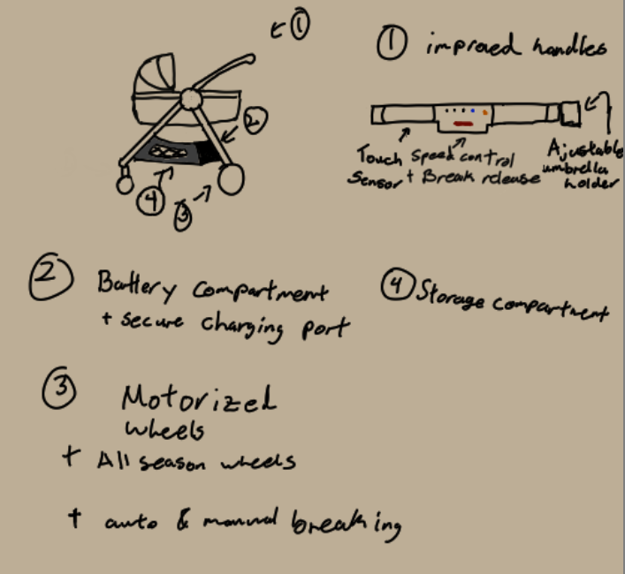

**Description**: The intervention that is featured in this design is the motorized back wheels designed to assist those who may have trouble pushing the vehicle. This also includes wheels designed for all seasons, allowing for better traction during rainy and colder seasons. As a safety precaution, the handle has touch sensors to detect when someone is holding onto the handles. If the user were to suddenly release their hands from the device, the motors will instantly stop and the breaks will be engaged. The motors will have variable speeds that can be cycled through, and an adaptability option, where the speed at which the vehicle will move is based on the force applied to the device. The batteries will be stored above the back wheels to lower the center of gravity whilst operating the vehicle. Above the battery pack will be a safe compartment that can charge your phone and safely lock away any potential valuables. The battery pack will also be detachable for easier charging fast and fast replacement. Beside the battery compartment will be a large general storage compartment made of polyester cloth and mesh. The folding mechanism comes from the center joint where the entire device will fold into a semi flat rectangular prism for easier storage.

For this second iteration of the design utility was the main focus. The motorized wheels and all-season wheels aim to improve the accessibility of the vehicle for those with trouble walking or producing enough force to move the vehicle. The handles are designed with safety in mind such that if accidental release of the vehicle were to occur then the vehicle will break automatically. A larger and sturdier storage compartment was integrated into the design to allow for better access and utility of the stroller.

**Usage scenario**:

1. Setup
2. Unplug the batteries if charging
3. Unfold the wheels and handles until they click into place
4. Attach overhead shade if desired
5. Attach battery if removed
6. Use
7. Place the child into the carriage
8. Secure the child with the seatbelt
9. Place any desired items into the storage
10. Place hands onto the touch sensors
11. Press the red button in the center of the handle to disengage the brakes
12. Enable or disable assistive walking
13. If enabled set desired speed (default is adaptive walking speed)
14. Begin to push the intervention
15. Put away
    1. Remove hands from the handles
    2. Check if breaks are enabled
    3. Remove child and any items in the storage
    4. Push the folding button
    5. Fold the device
    6. Either remove the battery or leave it in and plug it in to charge
    7. Leave in the desired storage location

# 

## design issues

**DC-1 Issues (Osman):**

* **Step 3b:** Deflating the shock-absorbing base may be hard for users with limited hand strength; an automated deflation mechanism would help.
* **Step 1f:** A self-adjusting or magnetic harness could improve accessibility for users with dexterity limitations.

**DC-2 Issues (Osama):**

* **Step 2c:** Requires audio cues to monitor the child, as they’re out of sight.
* **Steps 1 & 3:** Device setup and put-away require lifting, which may be challenging.

**DC-3 Issues (Codin):**

* **Step 1d:** A single-hand or push-button mechanism could improve accessibility for users with limited dexterity.
* **Step 2d:** Raising the low compartment would reduce strain for users with joint pain.

**DC-4 Issues (Andrej):**

* **Step 1e:** Limited strength and dexterity make it difficult to align the top part.
* **Step 2c:** Pushing with the chest provides more strength but excludes users with chest pain or related issues.

**DC-5 Issues (Khiem):**

* **Step 1a:** Voice-commanded unfolding (“Open The Pod!”) allows hands-free operation.
* **Step 1b:** Handle auto-adjusts to height and tilts for ergonomic one-handed grip.

**DC-6 Issues (Yee Yin):**

* **Steps 1, 3:** Motorized wheels add weight, making it hard to lift.
* **Steps 2e-2g:** Control layout may not be intuitive, potentially causing confusion.

## CEC Analysis Charts

### DC-1 CEC Analysis (OSMAN):

### 

| HF DEMAND | US STEP WITH HIGHEST DEMAND (#, description | % Excluded | Comment |
| --- | --- | --- | --- |
| Vision | 3B - Make sure that the foot brake is engaged and the swivel wheel is disengaged | 0.8 | Requires visual confirmation in order to ensure the braking system is engaged, and the swivel wheel is locked into place. |
| Hearing | 1A - Easily unfold the device due to the 3-way locking mechanism | 0.9 | Requires auditory confirmation that the intervention is locked into the fixed position needed for proper use. |
| Concentration memory | 2G - The swivel wheel can be activated with the push-brake to accommodate maneuverability in tight  spaces | 2.6 | Requires remembering the specific actions of the push-brake which is a dual-function button, acting as a brake and to engage the wheel. |
| Strength & dexterity (dominant) | 1E - Adjust the modular seat to face away from the device or towards | 8.4 | Requires physical strength to change the seat position and dexterity in order to ensure the seat is in the correct fixed position. |
| Strength & dexterity (non-dominant) | 3D - Release all three locks of the seat and push downwards | 8.6 | Releasing three locks requires dexterity in order to accurately engage the 3 locks, as well as pushing the seat downwards demands for physical strength. |
| Walking and Mobility | 2D - Push the device , the suspension system absorbs any shocks or vibrations | 7.3 | Requires the ability to walk and manage the intervention over various types of terrain |

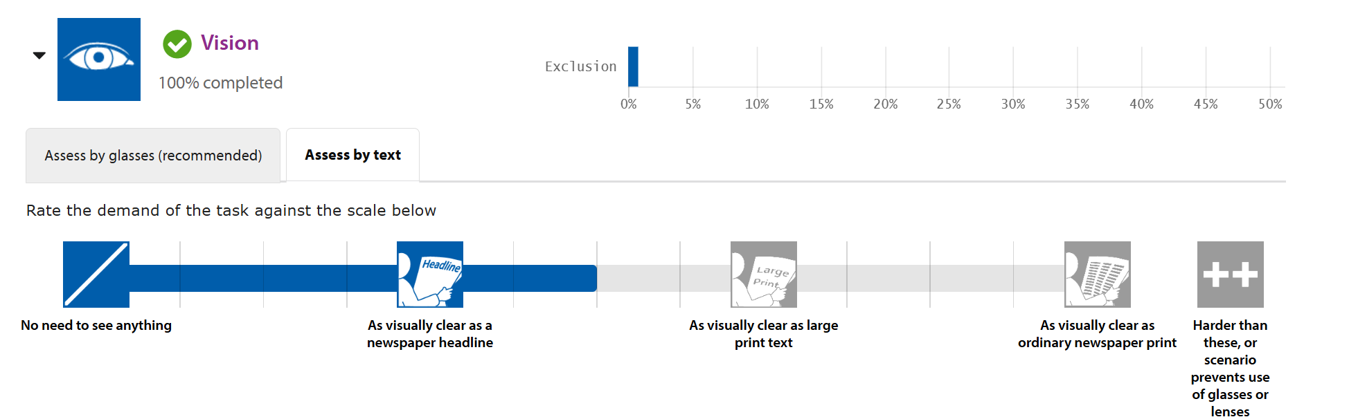

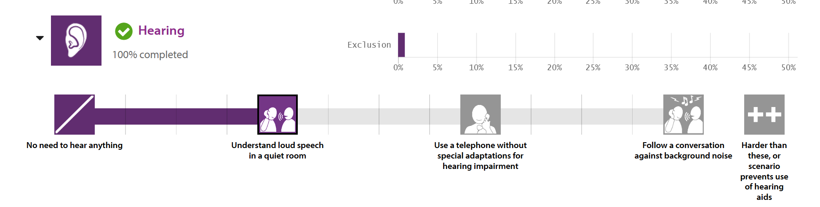

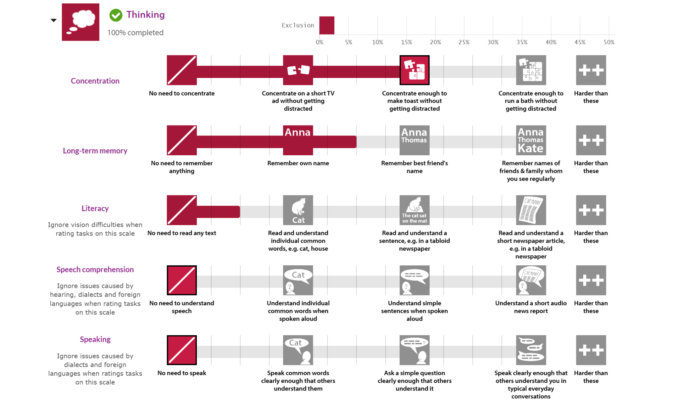

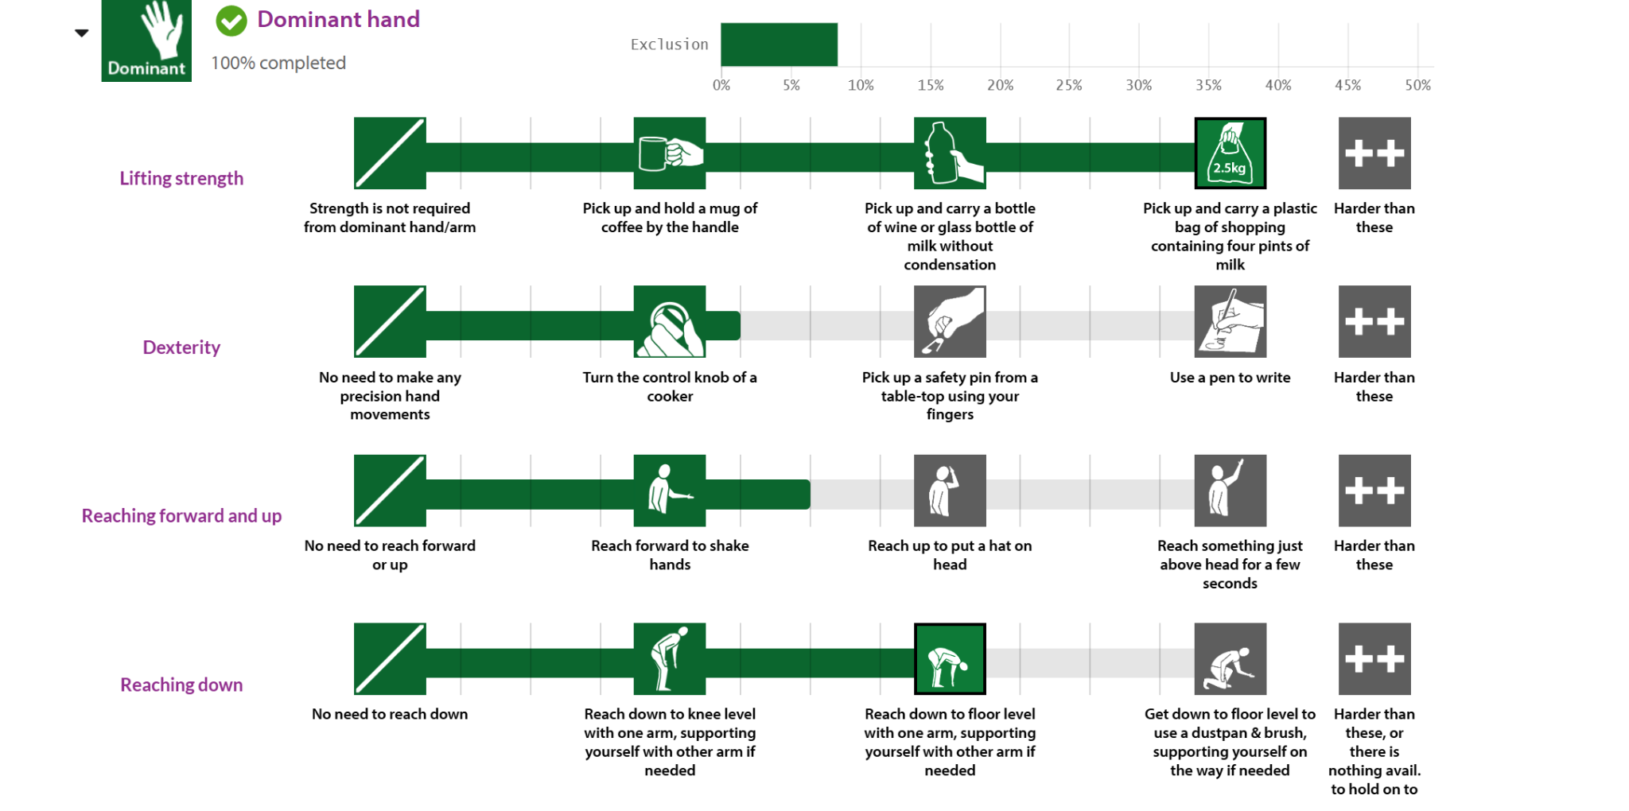

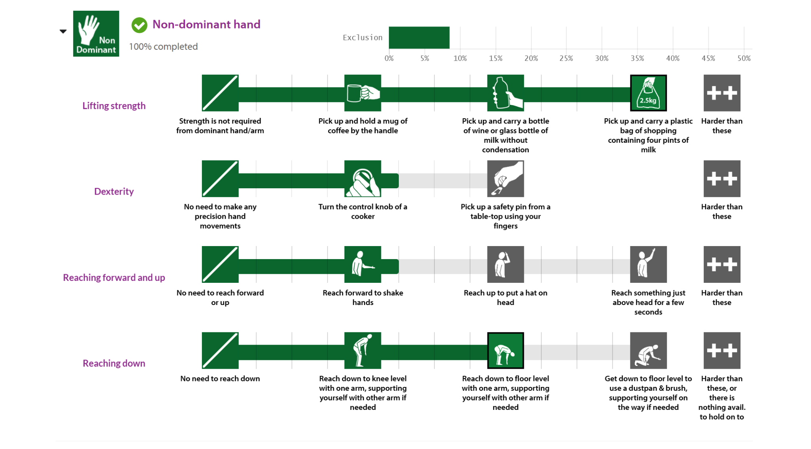r

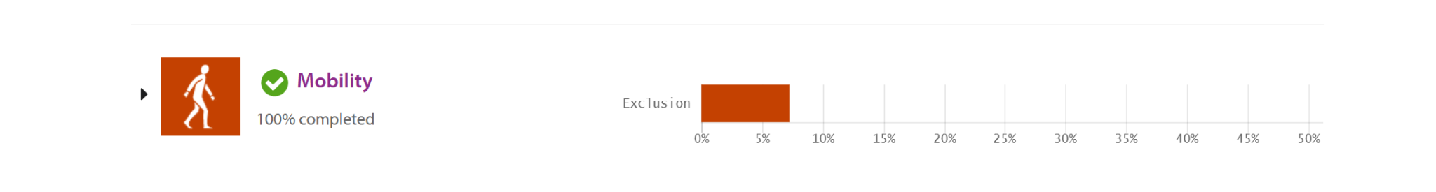

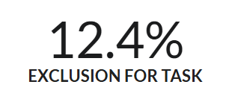

### DC-2 CEC Analysis (OSAMA):

### 

| HF DEMAND | US STEP WITH HIGHEST DEMAND (#, description | % Excluded | Comment |
| --- | --- | --- | --- |
| Vision | 2C: Pushing the intervention, looking at surroundings | 0.9 | Ensures the user can see potential obstacles, pedestrians, or changes in terrain while pushing the intervention, allowing for safe navigation and quick responses to hazards |
| Hearing | 2C: Pushing the intervention, hearing surrounding noises and child | 1.4 | Ensures the user is aware of their surroundings and the wellbeing of the child, as the child is out of sight from the user when in use. |
| Concentration memory | 3: Folding and storing the intervention | 3.4 | The user must identify that child is safely out of intervention before folding, and be able to concentrate on task of folding while being able to read and comprehend the folding instructions as given in the manual |
| Strength & dexterity (dominant) | 3: Folding and storing intervention | 7.8 | There is demand on the user to be able to lift and control the intervention |
| Strength & dexterity (non-dominant) | 3: Folding and storing intervention | 7.4 | There is demand on the non dominant hand to support the rest of the intervention while folding and storing is taking place |
| Walking and Mobility | 3: Folding and storing intervention | 6.1 | There is demand on the user to stand without holding onto any support while folding the intervention, as well as walking short distances around the intervention |

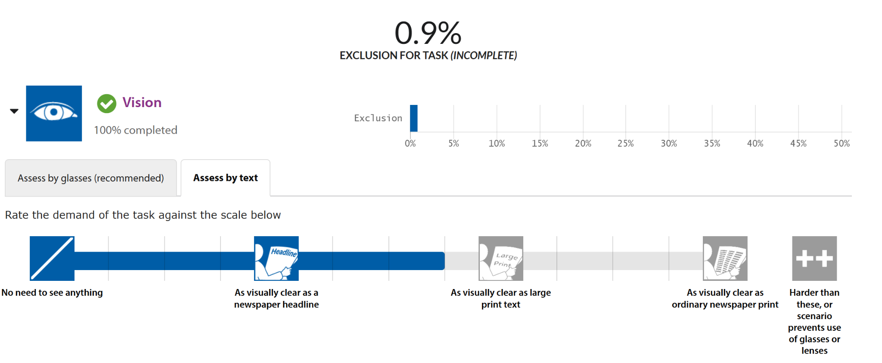

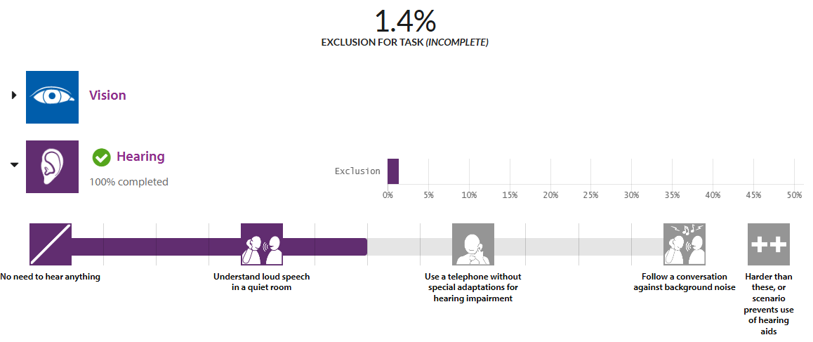

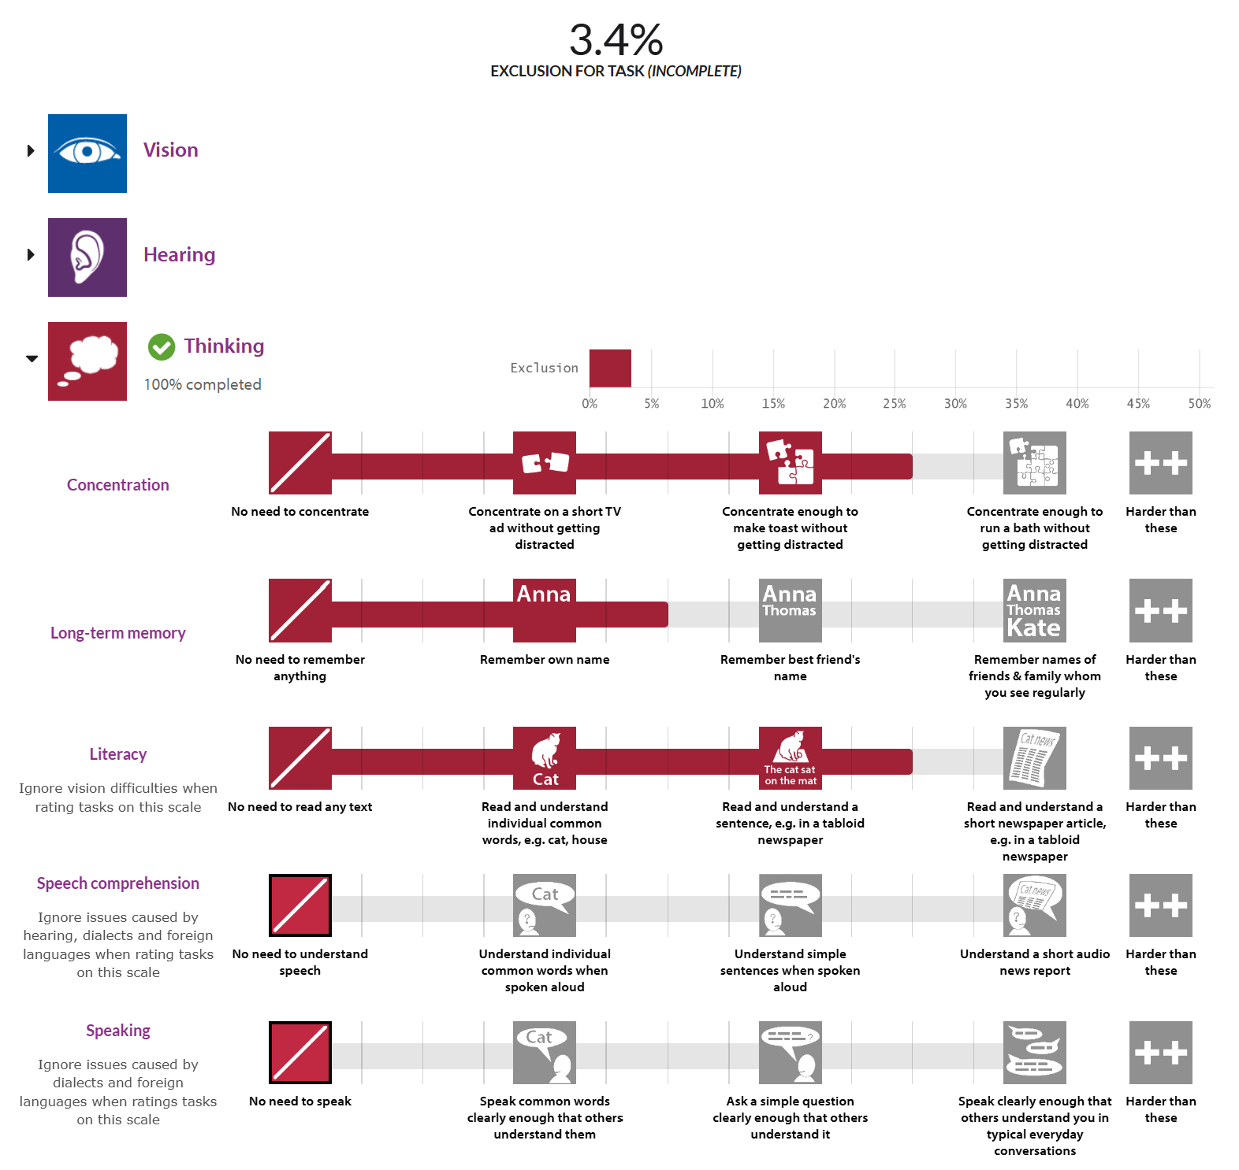

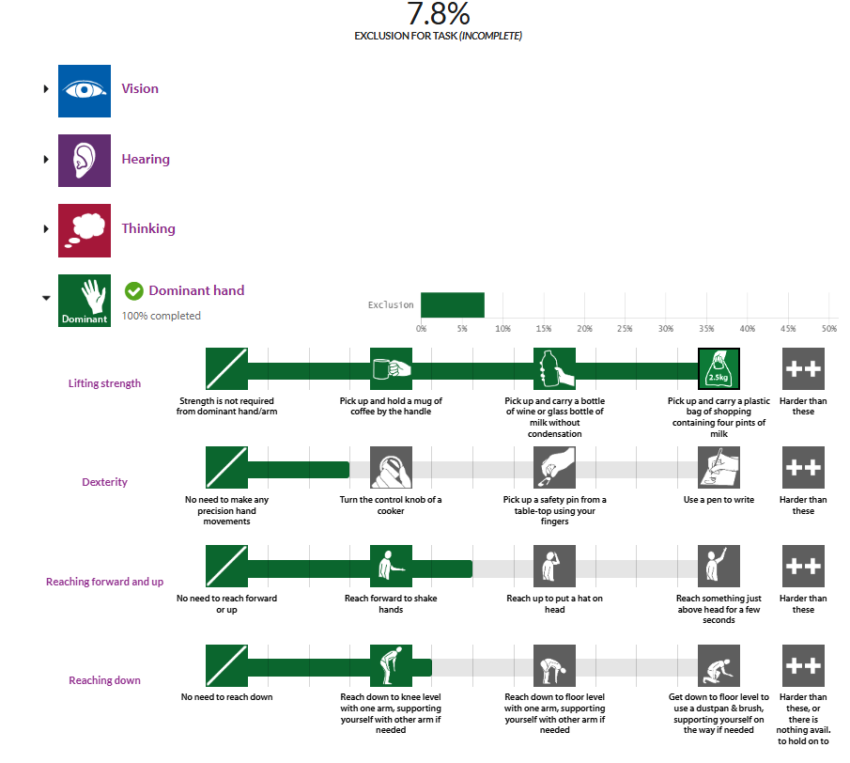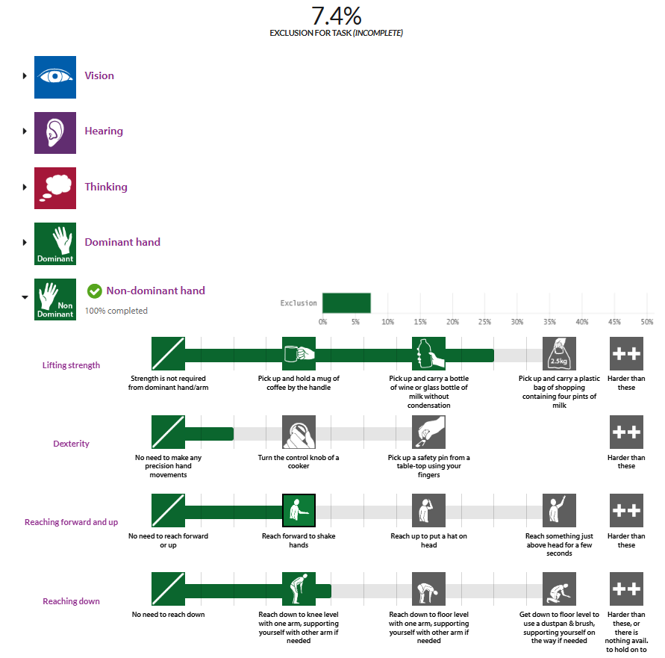

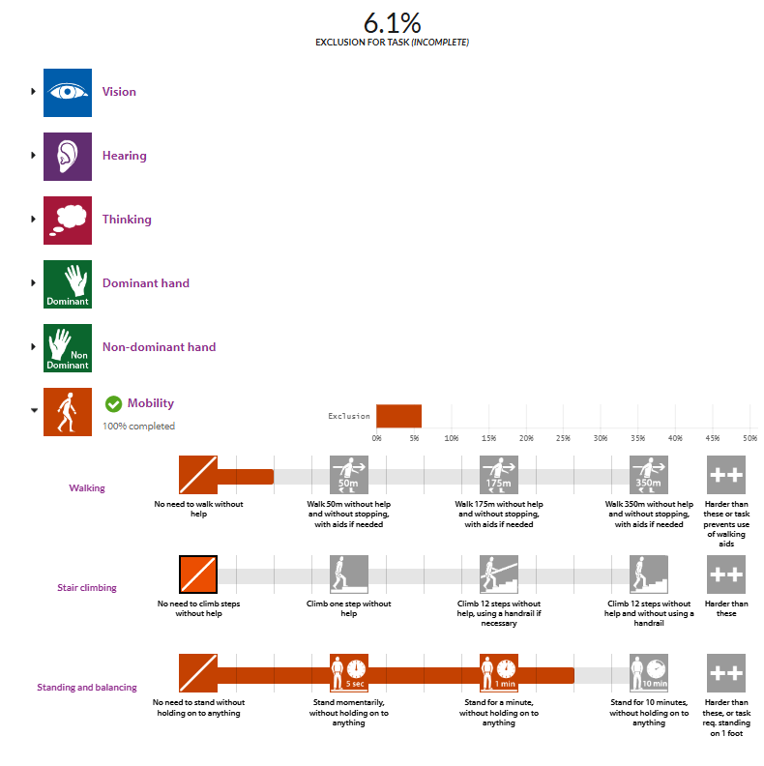

### 

### DC-3 CEC Analysis (CODIN):

| **HF DEMAND** | **US STEP WITH HIGHEST DEMAND (#, description** | **% Excluded** | **Comment** |
| --- | --- | --- | --- |
| Vision | 3b: emptying the intervention | 0.9% | The user must visually confirm the child is out of the seat/crib and is at a safe distance, and ensure there are no items left in the storage compartment. |
| Hearing |  |  |  |
| Concentration memory | 3: Setting up the intervention | 3.3% | The user must identify the proper configuration for their child while remembering the proper order to unfold the device. |
| Strength & dexterity (dominant) | 3: Setting up the intervention | 6.1% | The user is required to use forceful bending and lifting movements needed; needs two handed manipulation. |
| Strength & dexterity (non-dominant) |  | 6.1% | The user is required to use forceful bending and lifting movements needed; needs two handed manipulation. |
| Walking and Mobility | 2:Pushing and walking intervention | 11.3% | The user must walk 350m without help and without stopping, with aids if needed |

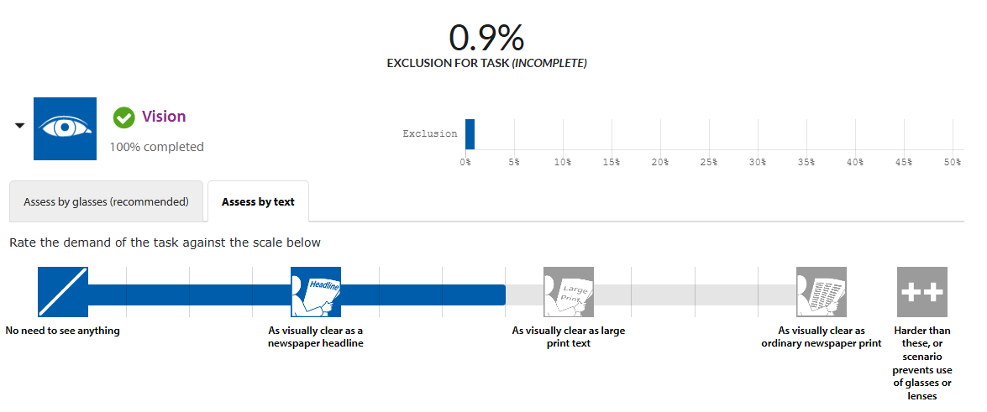



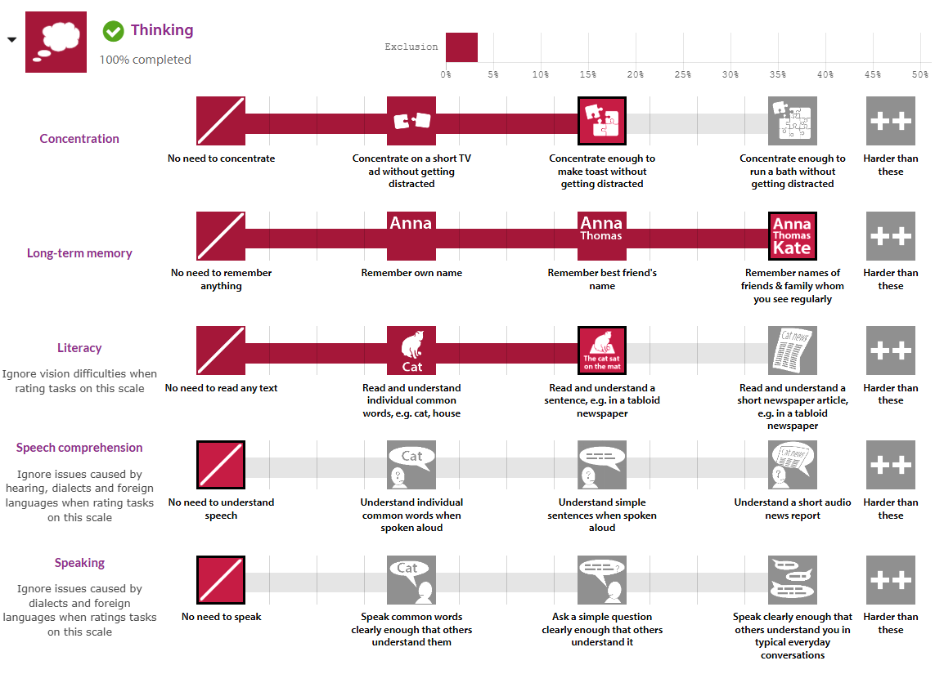

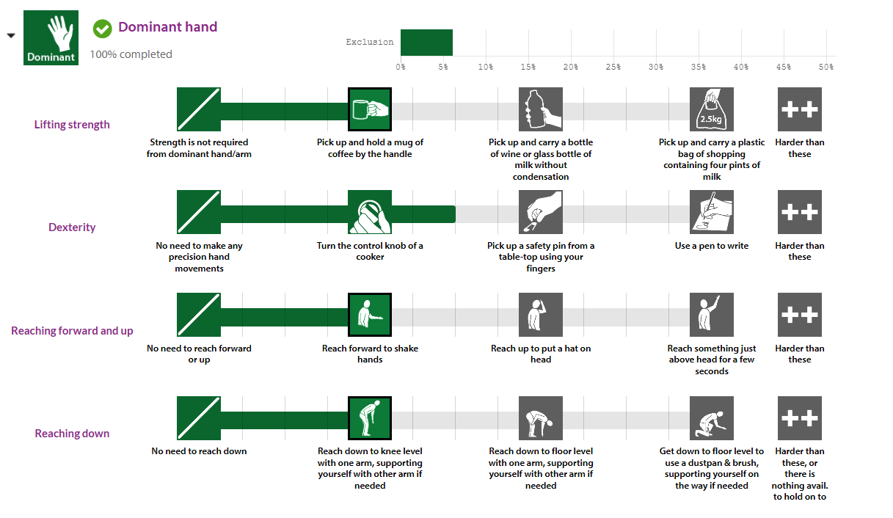



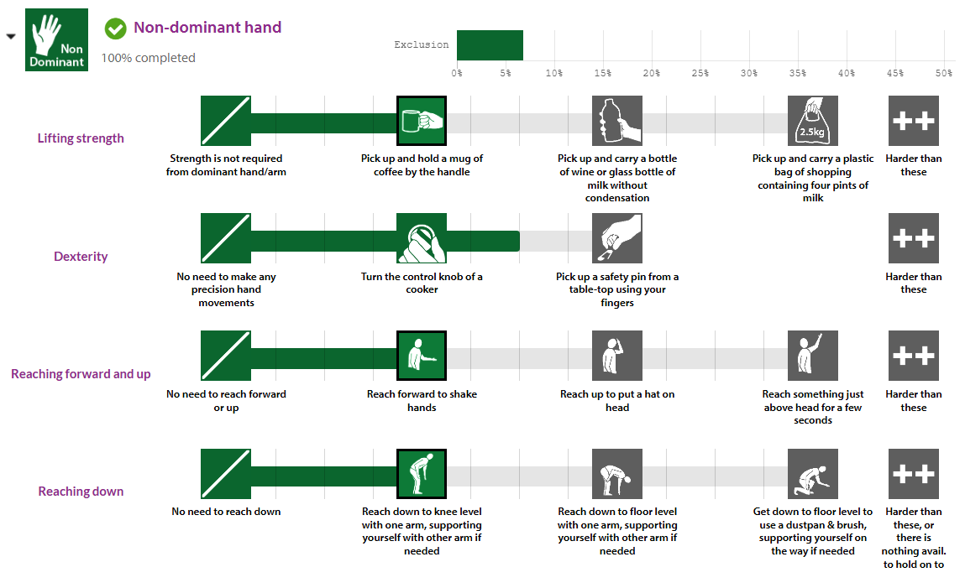



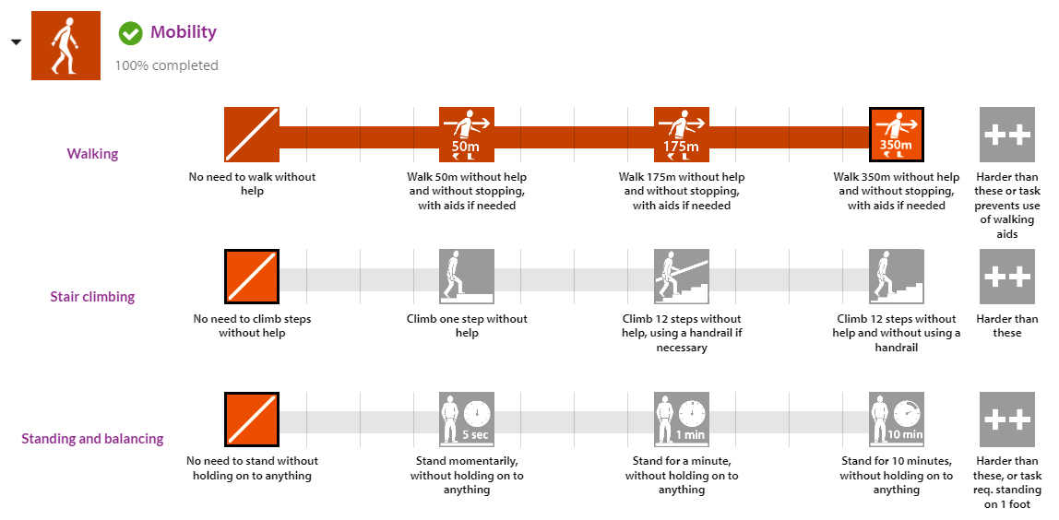

### 

### DC-4 CEC Analysis: Andrej

| **HF DEMAND** | **US STEP WITH HIGHEST DEMAND (#, description** | **% Excluded** | **Comment** |
| --- | --- | --- | --- |
| Vision | 1b: Remove pin joint cover | 0.8% | The user must be able to visibly see and find the pin joint cover to remove it |
| Hearing | 2e: Disengage the foot parking brake, push | 0.9% | User must be able to monitor surroundings and occupant of intervention for danger and other obstacles. |
| Concentration memory | 2b: Adjust restraints so the occupant is comfortable yet secured in place | 2.8% | User must be able to know how to adjust the seat restraints. User must also remember preferred settings for the occupant. |
| Strength & dexterity (dominant) | 1d: Continue holding the latch, unfold the wheelbase into its normal position | 6.3% | User must be able to move the weight of the wheelbase, assisted by gravity using the dominant hand |
| Strength & dexterity (non-dominant) | 1c. Press latch, and unfold the top half upright | 6.9% | User must be able to find the latch, depress it, and keep it held for the duration of the unfolding. |
| Walking and Mobility | 2e: Disengage the foot parking brake, push | 7.7% | User mist be able to travel longer distances while waking, having the intervention act as an aid. As well, user must be able to engage/disengage foot parking brake |

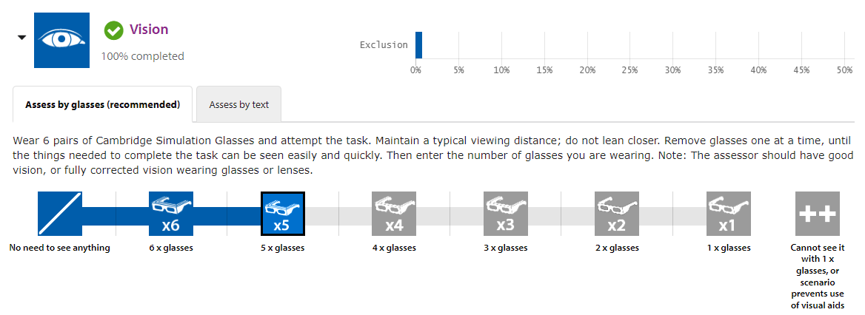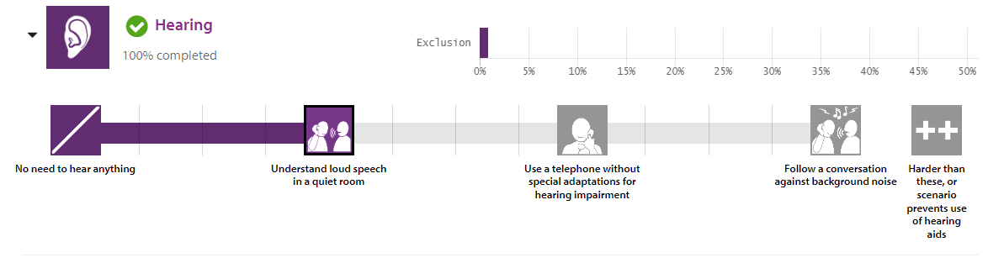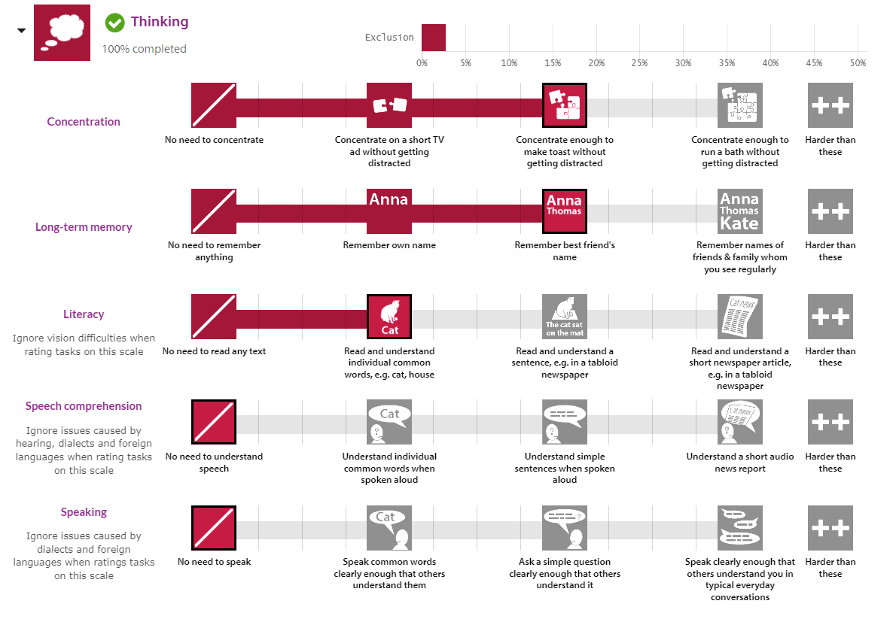

### 

### 

### 

### 

### 

### 

### 

### 

### 

### DC-5 CEC Analysis (Khiem):

| HF DEMAND | US STEP WITH HIGHEST DEMAND (#, description | % Excluded | Comment |
| --- | --- | --- | --- |
| Vision | Steps 2a-2c: Place child in seat, adjust sunshade, and store items in storage area | 0.9% | The user must visually confirm the child is seated securely, adjust the sunshade as needed, and ensure items are properly placed in the storage area. |
| Hearing | Steps 1c, 3c, 3e: Audible feedback from buttons during unfolding, folding, and locking operations to confirm actions, especially helpful for users with visual impairments | 0.9% | The user must listen for audible feedback from buttons during unfolding, folding, and locking to confirm each action has been completed successfully. |
| Concentration memory | Steps 1-3: From retrieving the pod to storing it properly in the designated location | 2.5% | The user must recall the steps involved in retrieving, setting up, and storing the device properly in the designated location, keeping track of each action. |
| Strength & dexterity (dominant) | Steps 1c, 1d, 2a: Press folding, unfolding button and secure child | 6.1% | The user must press buttons for folding and unfolding the device and secure the child in place, requiring moderate strength and dexterity in the dominant hand for these actions. |
| Strength & dexterity (non-dominant) |  | 0% | No significant strength or dexterity required, as stabilization is automatic upon button press, and minimal input is needed from the non-dominant hand. |
| Walking and Mobility | Steps 2e-2g: Disable parking brake, move pod, brake, and steer pod while walking | 11.6% | The user must be able to walk short distances, navigate urban environments, and carry the device when needed. The device should allow for steady movement without causing strain, enabling the user to walk comfortably without additional support. |

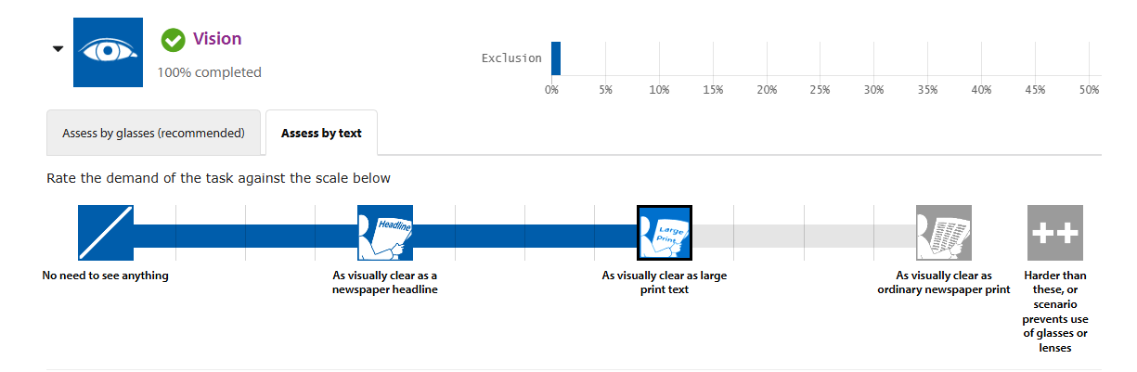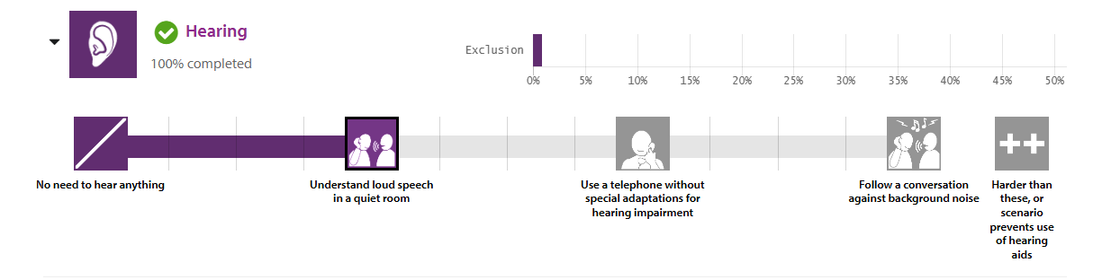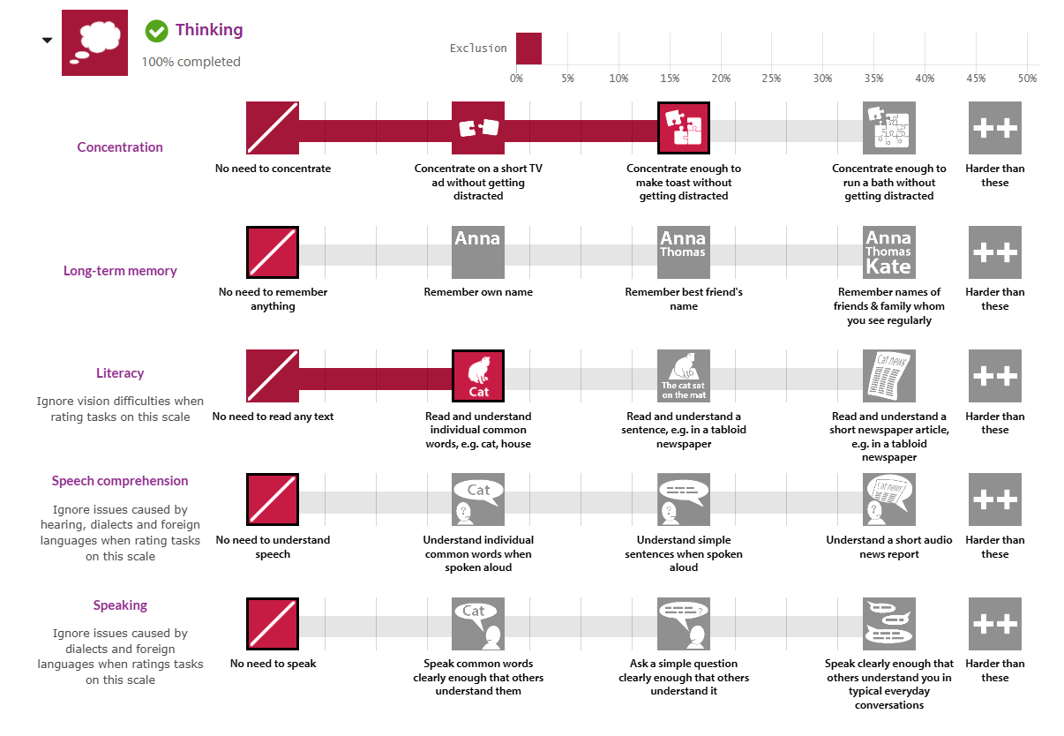

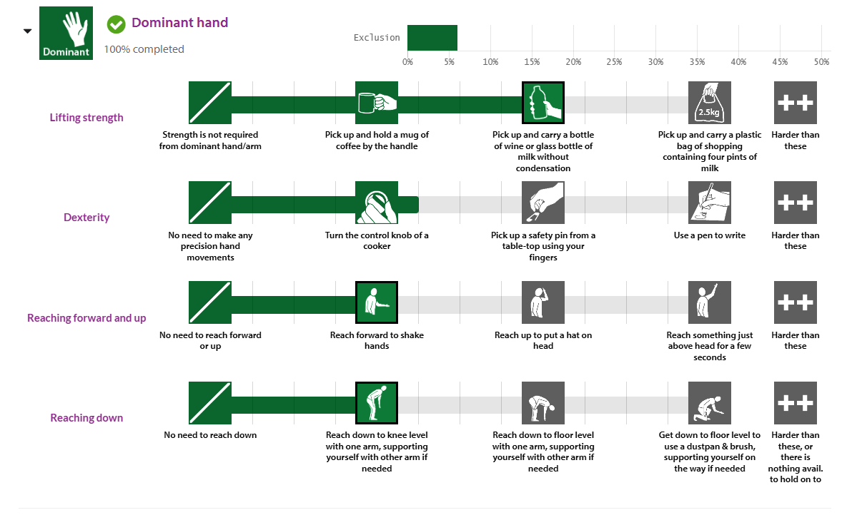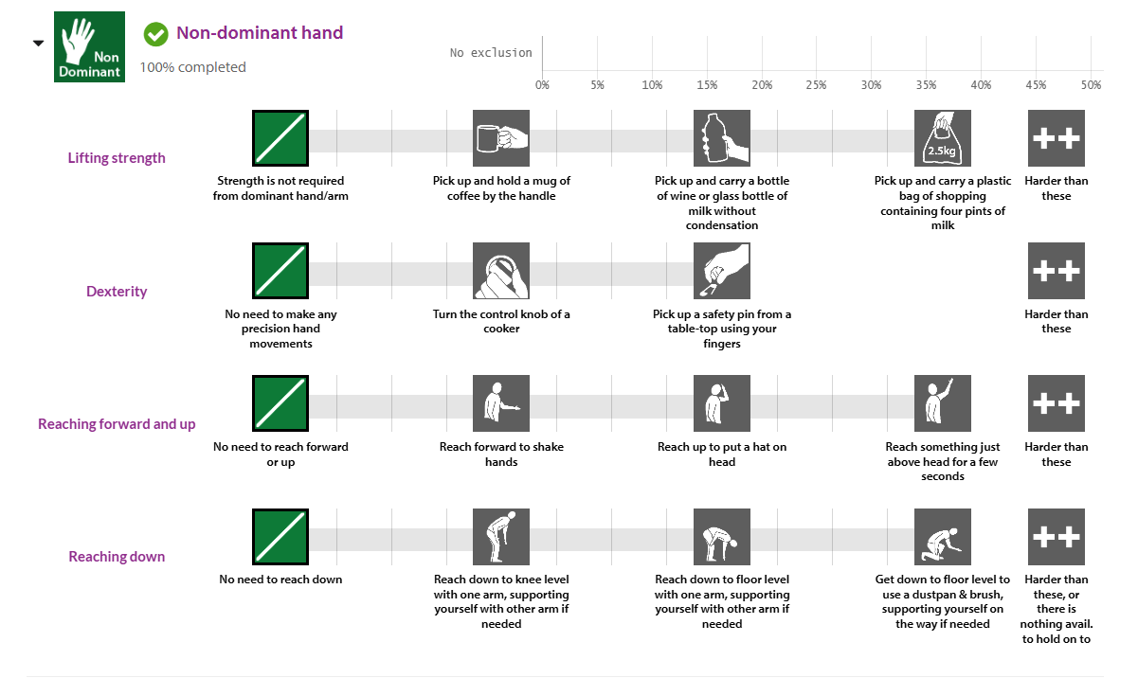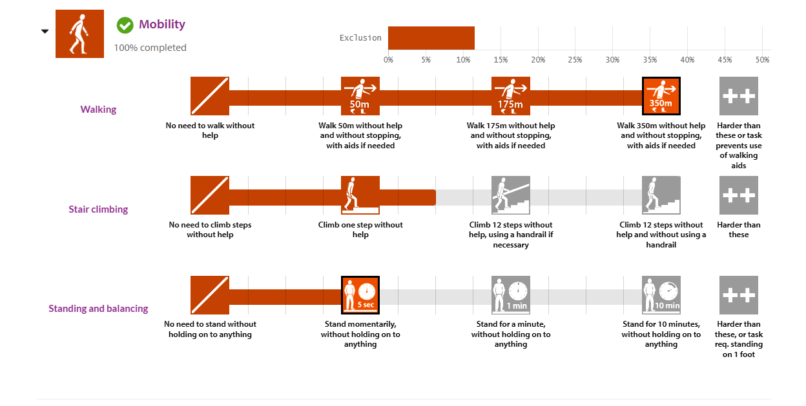

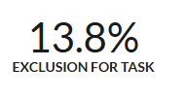

### DC-6 CEC Analysis (Yee Yin):

| HF DEMAND | US STEP WITH HIGHEST DEMAND (#, description | % Excluded | Comment |
| --- | --- | --- | --- |
| Vision | Steps 3c | 0.9% | Whilst removing anything remaining in the device the user must visually confirm that nothing is left in the storage compartment and the child can be safely removed. |
| Hearing |  |  |  |
| Concentration memory | Steps 3f | 3.3% | When storing the device, remembering to plug in the batteries for charging is important for the function of the device. |
| Strength & dexterity (dominant) | Step 3 | 5.9% | Lifting the vehicle for storage would require a reasonable amount of strength to fold and store away. |
| Strength & dexterity (non-dominant) | Step 3 | 6.4% | Since the vehicle is quite heavy, assistance from the non dominant hand is required for the storing the device |
| Walking and Mobility | Step 2h | 11.7% | Even though this is designed to assist the user whilst walking, the ability to propelle one's self whilst pushing the vehicle is required. |

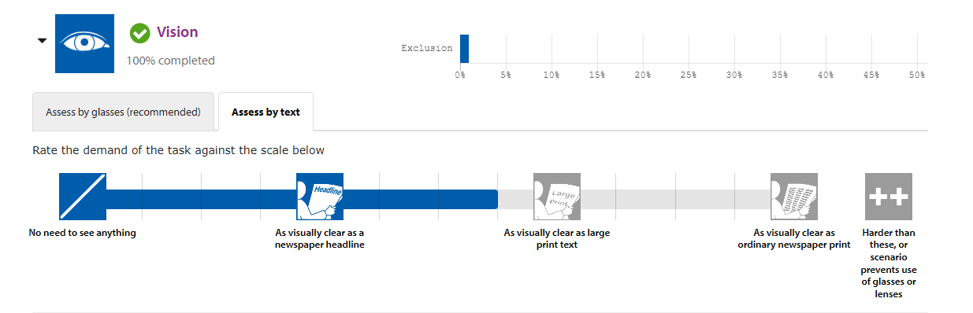

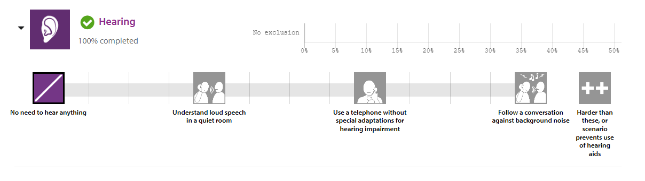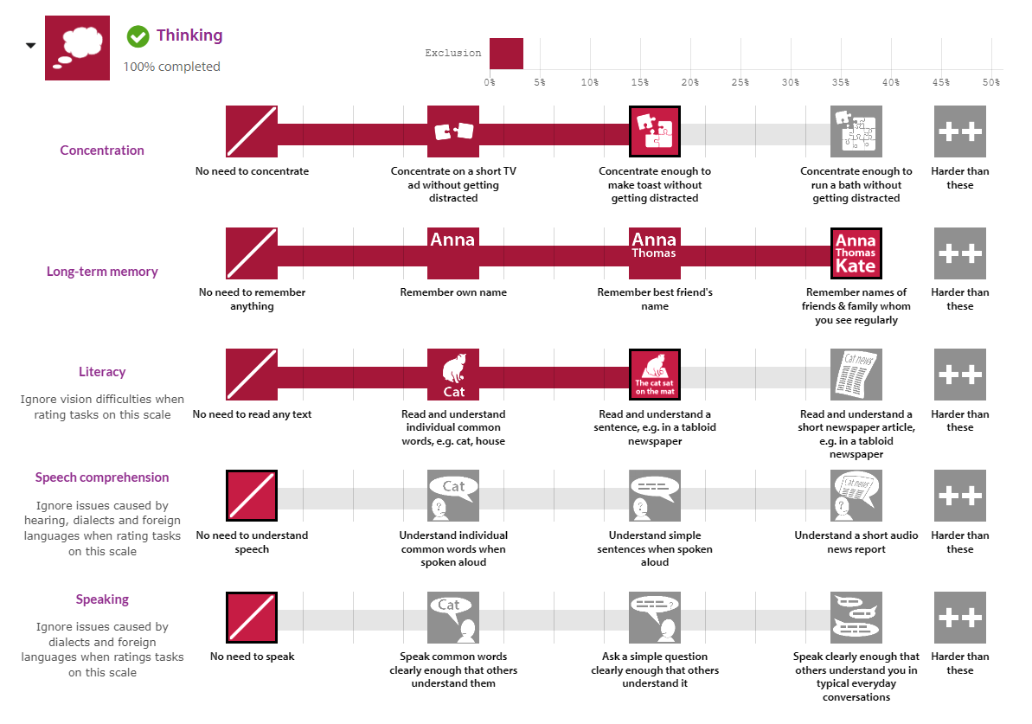

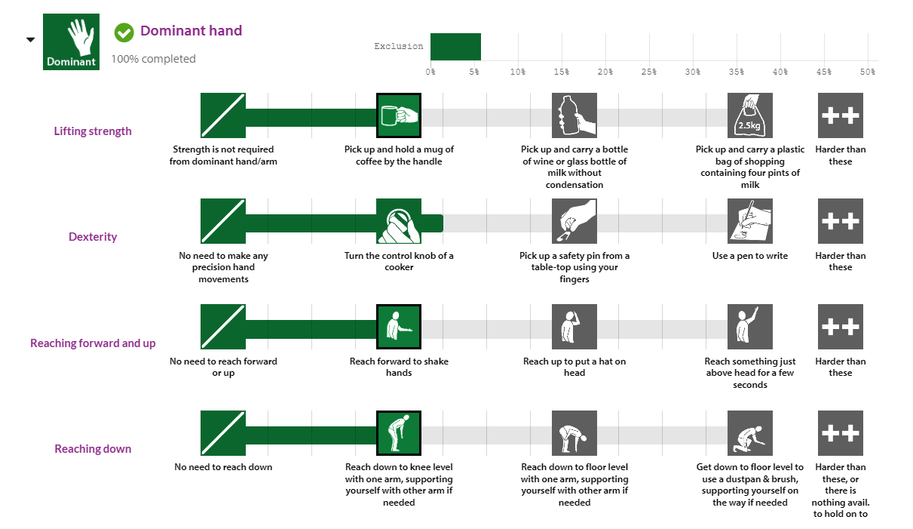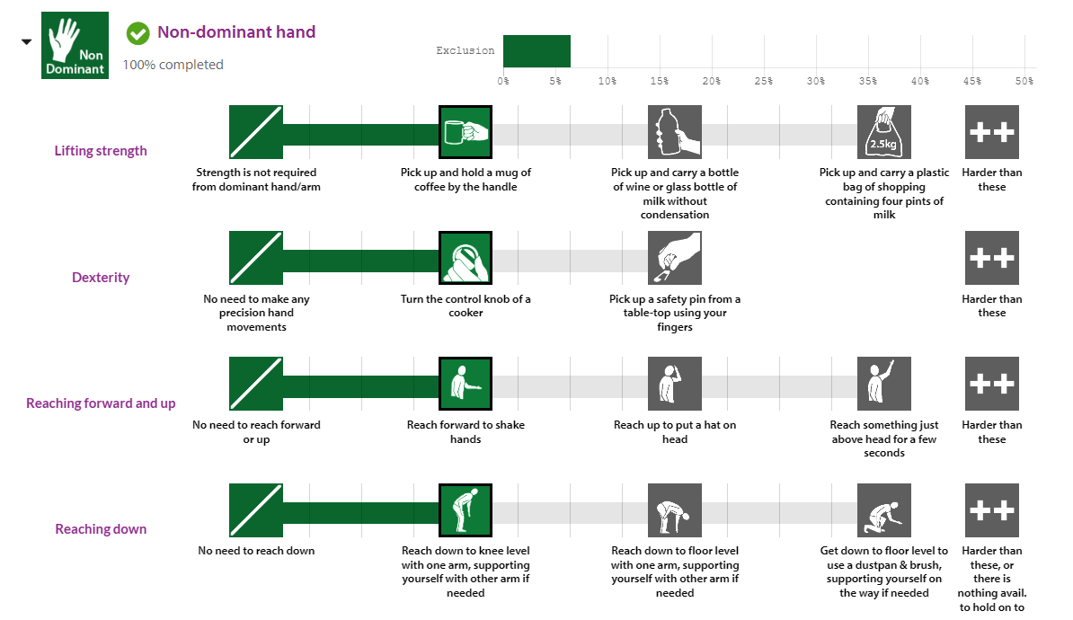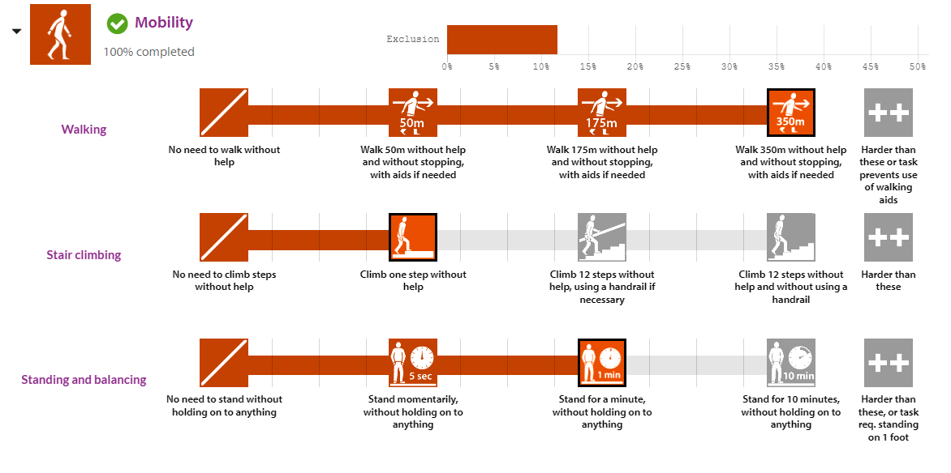

### 

# references

[1] [Situational Knowledge Base](https://docs.google.com/document/d/1rz1rAIiTk1ZrDwnuDpjA3R7Bg03I_6vg5hg59ztqgEg/edit?tab=t.0)

[2] [Product Requirements Specification](https://docs.google.com/document/d/1koir-KUa0VVEAbeYr69YBJmGd06drHKx8WeN1O9Ox0A/edit?tab=t.0)

[3] [Product Design Specification](https://docs.google.com/document/d/19KGi0PIx9DB-yrT7nRob-Qy8iMO80u0HPKYj3moV8S4/edit?usp=sharing)

[4] Inclusive Design Toolkit, 2024, "Capability Loss Calculator," Inclusive Design Toolkit, University of Cambridge, Cambridge, UK, accessed Nov. 11, 2024,<https://calc.inclusivedesigntoolkit.com/>

[5] [Design Brief](https://docs.google.com/document/d/1m8Y97Fyu418LrBMM7_kaH58dcY6xXEpoC8NbKqFQzBs/edit?tab=t.0#heading=h.plg5fdf1bsja)

1. Only the last 5 digits of the student number are required.